Easter Revision Session One

Active revision strategies for History
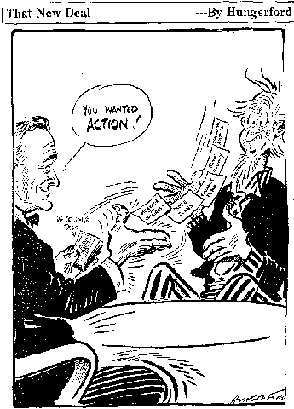
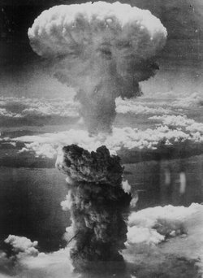

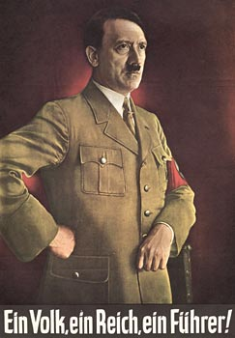

Introduction

What is your idea of revising?

It is trawling through lots of old exercise books?
Sitting in your bedroom on your own reading all your old notes?
Spending hours and hours away from your friends?

These ideas are a traditional image of revising. It is also an ineffective way of learning any material in depth. Let me share with you some educational theory.

When learning new material, people can generally recall -

10% of what they read
20% of what they hear
30% of what they see
50% of what they both see and hear
70% of what they say
90% of what they simultaneously say and do
Therefore, according to this theory, that traditional image of sitting alone for nights on end reading through your course notes has only a very limited impact..

Revision needs to be active and allow you to interactive with the material. This can be done in many ways and can be done on your own as well as with friends and family. What follows are a range of active revision ideas that you can easily incorporate in your revision plan.

Remember active revision strategies do not always need you to write things down. So long as your are using material in a constructive way, whether that is in quizzes, card games or discussions then you are learning – and sometimes you do not even realise it!

Acrostics

These are devices, such as a rhyme, a story or an acronym, which aid the memory. In some subjects similar techniques are used in learning key terms. To help you grasp the idea of acrostics there are some examples and ideas on the next page.

The key principles [SOLAR] to follow when using mnemonics are –

Symbols
The use of visual symbols is effective in representing information in simple and memorable ways.

Outstanding
We are more likely to remember mnemonics that are outstanding or outlandish. Be creative!!!

Links
Acrostics make clear links between symbols, words and information.

All five senses
Acrostics should use as many sense as possible. Make it active, it could be a chant, a monologue, a song or a drawing.

Repetition
We also remember acrostics through repetition. Good ways of remembering acrostics are –
Explaining them to friends.
Keep a written record of them using creative note-taking techniques using symbols and colour.
Swap acrostics with friends.

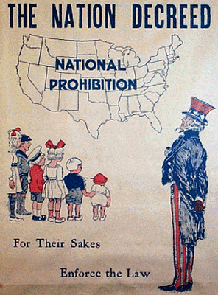
BIBWASS – Impact of prohibition

Bootlegging

Ignored laws
Bribery of agents
Wickersham Commission
Al Capone
Smuggling
Speakeasies

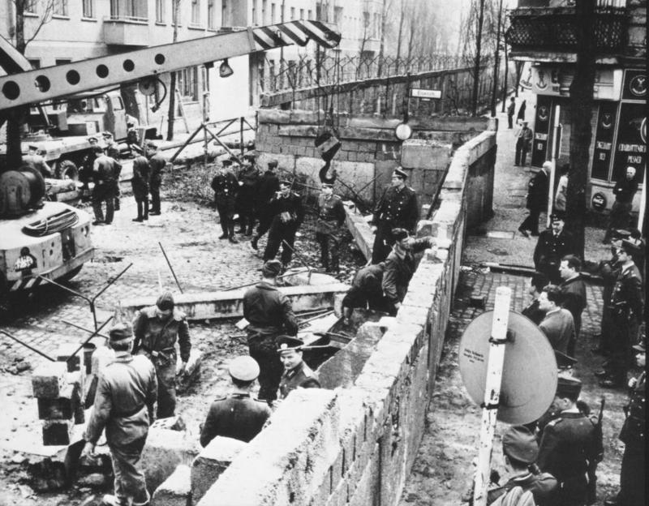
SCUD – reasons why Berlin Wall was built

Summit failure at Vienna
Cuban problems
U2 incident
Defecting Germans from East to West
HOOFPUS – Nazis tactics to win power in the 1930’s

Hitler’s leadership
Organisation of party
Opposition divided
Flexible messages
Propaganda
Use of technology
Support from industrialists and middle class
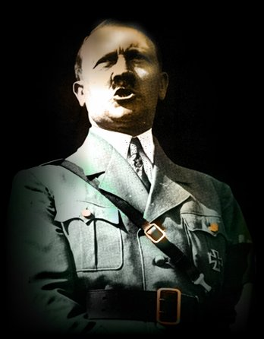

Effective note-making strategies for revision

General tips for handling texts to make revision notes

In the run-up to the exams you will spend a long time taking revision notes from a range of sources – textbooks, handouts from teachers and your own class notes. Instead of copying out these notes try to work towards developing a portfolio of summary sheets.

For each topic, summarise your notes using the following ideas –

Using annotations
Whatever text you are revising, it is useful to write key words/ideas in the margins. Annotations are best written using different colours and symbols.

Key words
You do not need to write full sentences when writing revision notes. Try summing up each sentence using just one word. With these words you can then create mnemonics to help you remember them.

Symbols
If you are a visual learner, you can use symbols instead of words when annotating.

Colour
When revising, use a range of colours to highlight key words and ideas in your notes. You can use different colours to highlight different types of information such as causes, events and consequences or when looking at exam questions highlighting in different colours pieces of evidence and points of analysis within the question.

Summary or mind maps

Summary or mind maps are best used for more complex texts as well as summarising large blocks of information such as an entire topic. The process of creating mind maps is the same as making revision notes as you should annotate and highlight key points in your notes before you start to create a mind map.

Using mind maps should be a five-stage process –

A central title
Begin with a blank page of plain paper in landscape format and then write the title in the middle of the page e.g. Prohibition.
Placing the title in the centre of the page emphasises that it is central to the topic.
Enclose the title by drawing a shape around it.

Dividing up the text into sections
Divide the text into 2-6 sections e.g. Causes of prohibition, key acts, reaction to prohibition, organised crime and why did prohibition failed.
Before taking any further notes think about the layout of your mind map.

Branching out
Mind maps represent information like a tree branching out from the centre to the edges of the page.
Begin a ‘two o’clock’ by drawing a thick branch and write of the top of the branch a single key word as a sub heading – one of your sections in step 2.
To make best use of the space draw curved branches off this main branch and write on these smaller branches the key words and symbols linked to the sub-heading/main branch.
Repeat with all sections and make it as colourful as possible.

Memorising summary/mind maps
Mind maps provide concise and powerful summaries of complex topics and are an effective way of reviewing topics already learnt.
Some tips to help you remember information in mind maps are –
Pay attention to the key words on all the branches.
Try to describe the map to somebody else.
Use lots of colours and symbols in your maps.

Test yourself
Place a blank piece of paper over your map and trace just the branches.
Put the original map out of sight and then fill in your skeleton map from memory filling in as many of the key words as possible.
When you have finished, look back at the original and use a different colour to correct any mistakes and omissions.

On the following pages, there are two worked examples of mind maps completed by GCSE History students. The examples should give some ideas on how much information you should include, how to incorporate pictures and colour and what topics you can use mind maps for.

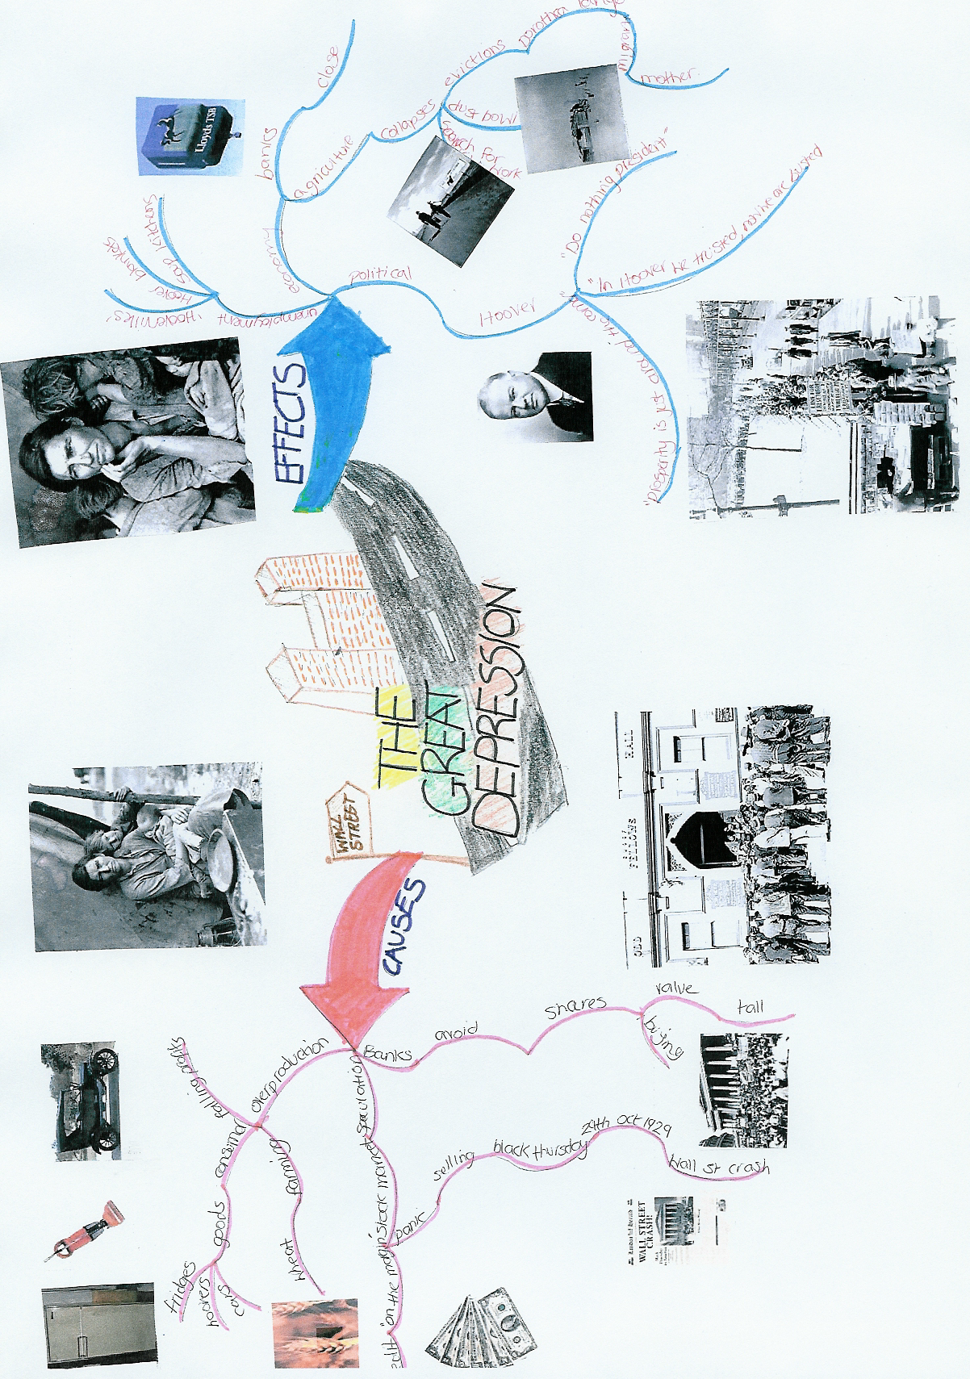

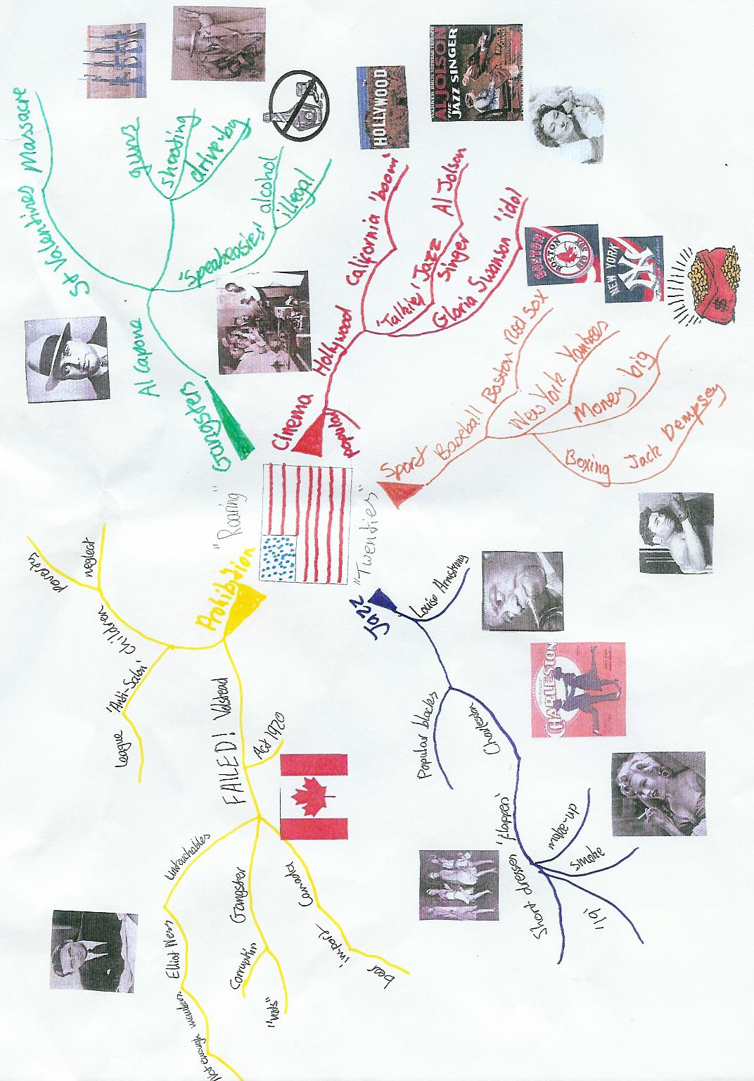

Hierarchies

This note-making exercise is applicable to history topics text as most of this type of information is made up of hierarchies of information. Identifying the different hierarchies or layers in information can provide the structure for effective revision notes in an interactive process.

In this method of making notes, you should draw a page-sized pyramid which five different layers. Copies of blank pyramids will be available with this booklet.

In the first layer of the pyramid at its apex, write the big idea in the text. This could be the title, or topic. Then in the second layer, write the next level of information – the big ideas/aims of the topic. In the third layer, write the key points of the topic. Finally, the details are written at the base of the pyramid [the final two layers].

The shape encourages you to recognise that there is usually one big idea, two or three main points and then lots of detail. Organising your exam notes in this fashion helps you to interact with your notes and tease out the different types of information you need to deal with.

Effective card games/activities for revision

Card games and activities are effective type of revision strategy in learning material and improving memory skills. Card games can be used with friends learning the same material and help understand complex ideas by encouraging discussion of key ideas. These methods of peer revision can be very effective in deep revision of key material.

Cards games are more effective when you make your own cards. All sets of cards for revising History in this way require around 20 – 25 cards, each having a key term, event, person or year relating to the same topic written on them.

Guess Who?

This is a revision card game that can played between two or more people and can be used in a number of ways.
Choose a subject and topic that you wish to revise. This can be literally anything you wish, Economics, History, Geography, Maths, PE, English, etc.
On the grid, write on each card write a key fact, year, key term, character, element, formula and so on and then cut out the cards.
Now you can use these revision cards in a variety of revision games with a partner.

Game 1
Place the cards face down.
The first player takes the top card and the second player must ask questions to guess what is on the card. However, the only answer the first player can give is either 'yes' or 'no'.
Once the item has been correctly guessed, the turn passes onto the next player.
To make the game more challenging, you can set a limit on the number of questions and/or the time taken to correctly guess the item.

Game 2
Place the cards face down.
The first player takes the top card and must describe to the second player what item is on the card without using the word/words on the card.

Hide and seek

With this revision technique you need a set of blank cards about the size of business cards.
On one side of the cards you should write one half of the information you need to learn. This may mean a key year in History, a key term in Economics or vocab in German.
On the reverse of your cards you need to then write the corresponding piece of information. For example, on the opposite side of the key year in History write the event you need to learn, the definition of the key term for Economics and the meaning of the vocab in German.
Once you have written the cards, lay out the cards face up. The meanings/definition/key event is face down.
Then looking at the cards, give the meaning/definition/key event in your head, turn over the card to see if you are right. If you are turn the card over, if not leave the card face down and return to it after you have been round all the other cards.
You can only turn a card over if you have given the correct meaning/definition/key event.
Add to the challenge by timing yourself how long it will take you to finish the activity. The quicker you became the more effectively you learn the information.

Bingo

This card game should be complete with at least four people. The game requires one ‘bingo caller’ and the rest of the group will play bingo. Also two identical sets of cards are needed one set will make up the bingo cards and the other set is needed by the bingo caller to pick out of the bag.
Each person who is playing bingo takes 4/6/8 cards [depending on how long you want the activity to last] and arranges them like a bingo card.
The bingo caller has randomly picks a card from the set and rather than reads the card gives a definition of the word on the card. [E.g. Herbert Hoover is on the card. Teacher says ‘President of USA between 1928-32’]
All players who have the correct card turn it blank face up. The activity ends when a player declares a full house.
To check understanding the player must not only give all the words on his/her cards but also the correct definitions. If they cannot do this, the game continues until a player can give both correct words and definitions.

Dominoes

This activity can be complete in pairs
Using a set of cards from one topic, make links between three cards. [E.g. A link may be made with the cards – Prohibition, organised crime and Al Capone] the cards would be arranged as if as if you are playing dominoes.
To check understanding the person making the link in the pair must justify the link. If agreed the cards stay where they are.
Linking more cards together can develop this activity. If you are feeling really ambitious, with the topic name at the centre, you can use all the cards in the set and link them together. When this is completed this is, in effect, a mind map that can be copied down and used in your revision notes.

Talking History for revision

One of the best ways to learn about History is by talking about it! It goes for revision too. These activities help you learn about the key information in the GCSE History course verbally. The activities that follow aim to make students apply their knowledge about History as well as making revision memorable in an enjoyable way. These activities can be completed with any group size from two upwards.

What’s inside my head?

This is activity involves the teaching thinking of a key word/event/idea related to a topic. The person/people who are doing the guessing need to write 1/2/3 on a piece of paper.
The person who is giving the clues asks the group to guess the key word/event/idea they are thinking of by giving three clues to the answer. On each clue, the group members writes down beside their 1,2, 3 what they think the word is.
The clues range from the very broad to the last that is highly focused. Each clue is a separate round.
Example

Key event – Dunkirk Evacuation

Clue one – Event in the Second World War.
Clue two – Happened in 1940
Clue three – Involved the BEF crossing the English Channel.

What is the question?

On the on a piece of paper one person in the group gives rest of the group an answer, such as The New Deal. Group members need to think up a question for that answer.
This can be differentiated easily by challenging the group members to create two or more questions that all generate the same answer.
This can encourage effective discussion as well as check understanding.

Other useful History revision resources

The BBC Bitesize website are building up a library of revision podcasts. They have free to download podcasts that cover most of the topics that we are studying for GCSE History. They contain a condensed overview of a range of topics and make a fantastic revision aid.
Remember your text books loaned to your by the History department. They are written specifically for your History course and not only contain the key information you need to learn but also mock questions that will give you an idea on what you are going to face in June.
http://puzzlemaker.discoveryeducation.com/ - This website link takes you to a site where you can make your own puzzles, such as wordsearches and crosswords. These make-your-own activities are great to make and then share with your friends. You could be really nasty and make word searches to give them to your friends leaving out the list of words they need to find just to make it more challenging.

But always remember, the best revision resources are made by you! To go through the process of making resources helps you learn the material in depth and understanding.

Good Luck!

