 | Quality of the Presentation | Quality of the Argument
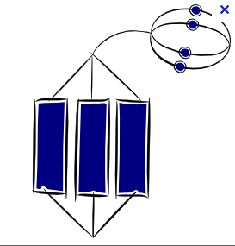  A*  9 - 10 | As below and…  the presentation has the confidence and professionalism that clearly demonstrates preparation, practice and conceptual understanding. | As below and…  a clear well-argued exploration of the representations leads to a judgement using appropriately selected evidence, the criteria and a good understanding of the period.
A  8 | As below and…  Speakers have clear roles. Presentation is clearly well planned and organised. Audience is involved through eye contact, questioning and interactive materials. | A clear judgement is given which references all three criteria. Similarities and differences between the reps are identified. Quotes are used to support the views expressed. Clear links to own knowledge of the period.
B  7 | All members of the group speak.  Presentation is clear and articulate.  Presentation materials support our understanding and don not distract from it. Audience is asked questions and thanked. | A judgement is given which references all three criteria. Similarities and differences between the reps are identified. Quotes are used to support the views expressed. Clear links to own knowledge of the period.
C  6 | Most members of the group speak.  Presentation makes sense.  Presentation is supported by materials.  Clear evidence of planning and effort. | Evidence is given using two of the criteria. However this is not fully developed and is only supported in a limited manner by selected evidence and own knowledge.  Simple judgement given on which representation is best.
D  5 | Some members of the group speak.  Presentation can be understood.  Some evidence of planning and effort. | Evidence is given to developed level but only focuses on one of the criteria. Little supporting evidence. Discussion is largely descriptive, with little evaluation or analysis.
E  3 -4 | One member of the group speaks and the others support but have no real or meaningful role.  Materials decorative and do not support understanding. | Judgement not fully given. No evidence is used to support simple statements. Descriptive narrative of events from the period with no evaluation or analysis.
U  <3 | None of the above. | None of the above.

