 | Quality of the Presentation | Quality of the Argument
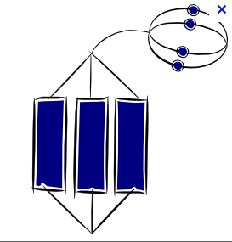  A*  9 - 10 | As below and…  the presentation has the confidence and professionalism that clearly demonstrates preparation, practice and conceptual understanding. | As below and…  a clear well-argued exploration of the statement leads to a judgement of the statement using appropriately selected evidence.
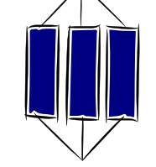  A  8 | As below and…  Speakers have clear roles. Presentation is clearly well planned and organised. Audience is involved through eye contact, questioning and interactive materials. | Clear judgement is given on the statement. Effort to link events to the wider political events in USA and USSR and the Cold War. Evidence is discussed to support views in favour and against the statement. Ideas like the Carter doctrine referenced.
B  7 | All members of the group speak.  Presentation is clear and articulate.  Presentation materials support our understanding and don not distract from it. Audience is asked questions and thanked. | A judgement is given which references both sides of the debate. Key features are discussed and links identified. Short comings of key features of détente are explored to provide evidence.
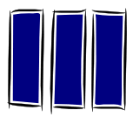  C  6 | Most members of the group speak.  Presentation makes sense.  Presentation is supported by materials.  Clear evidence of planning and effort. | More than 3 key features of Détente are discussed to a developed level. Causes of the start and end of détente explored.  Simple judgement given on the statement.
D  5 | Some members of the group speak.  Presentation can be understood.  Some evidence of planning and effort. | At least 3 key features of détente are discussed – SALT I/II, Helsinki, Ping Pong diplomacy, meeting in space. AND causes for start and end of détente are suggested.
E  3 -4 | One member of the group speaks and the others support but have no real or meaningful role.  Materials decorative and do not support understanding. | At least 3 key features of détente are discussed – SALT I/II, Helsinki, Ping Pong diplomacy, meeting in space OR causes for start and end of détente are suggested.
U  <3 | None of the above. | None of the above.

