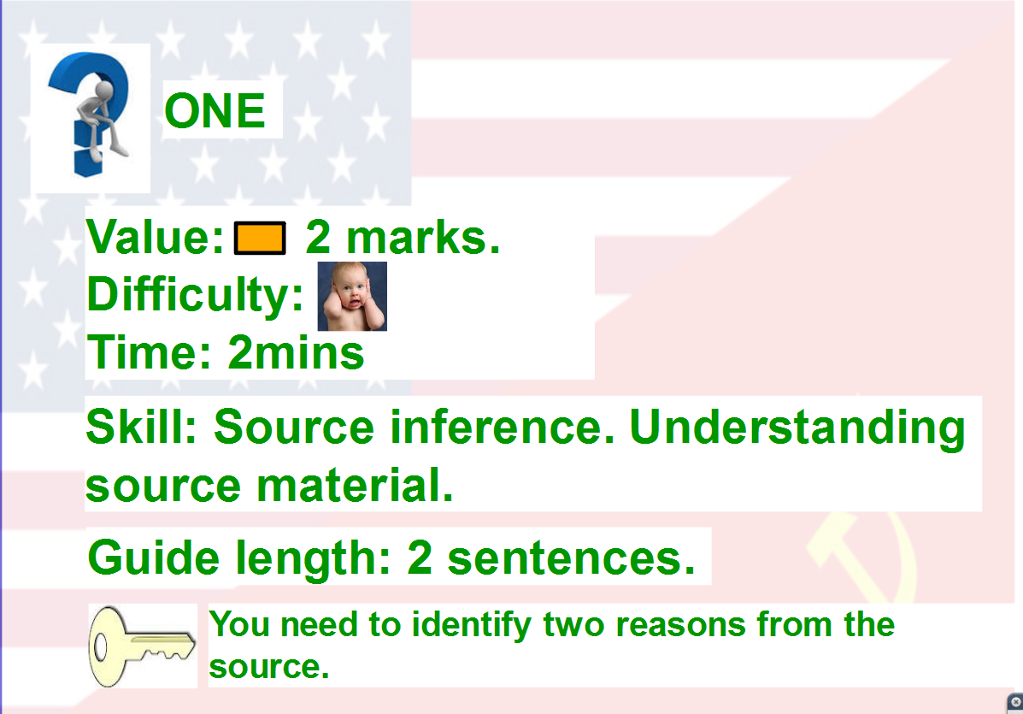

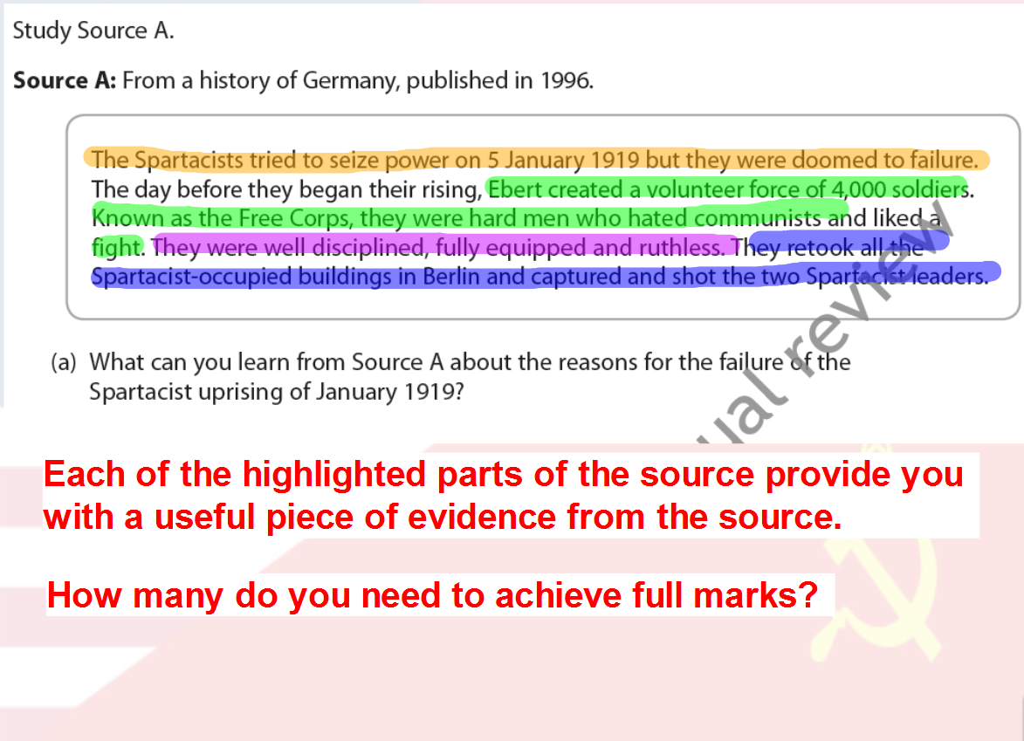

PRACTICE: question 1

Source A: General Marshall explaining the reasons behind his economic plan:
Aside from the demoralizing effect on the world at large and the possibilities of disturbances arising as a result of the desperation of the people concerned, the consequences to the economy of the United States should be apparent to all. It is logical that the United States should do whatever it is able to do to assist in the return of normal economic health to the world, without which there can be no political stability and no assured peace. Our policy is not directed against any country, but against hunger, poverty, desperation and chaos. Any government that is willing to assist in recovery will find full co-operation on the part of the USA.

- Give two reasons from Source A for the creation of the Marshall Plan in 1947? (2)

______________________________________________________________________________________________________________________
______________________________________________________________________________________________________________________
______________________________________________________________________________________________________________________
______________________________________________________________________________________________________________________

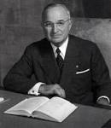
Remember folks you only need two!
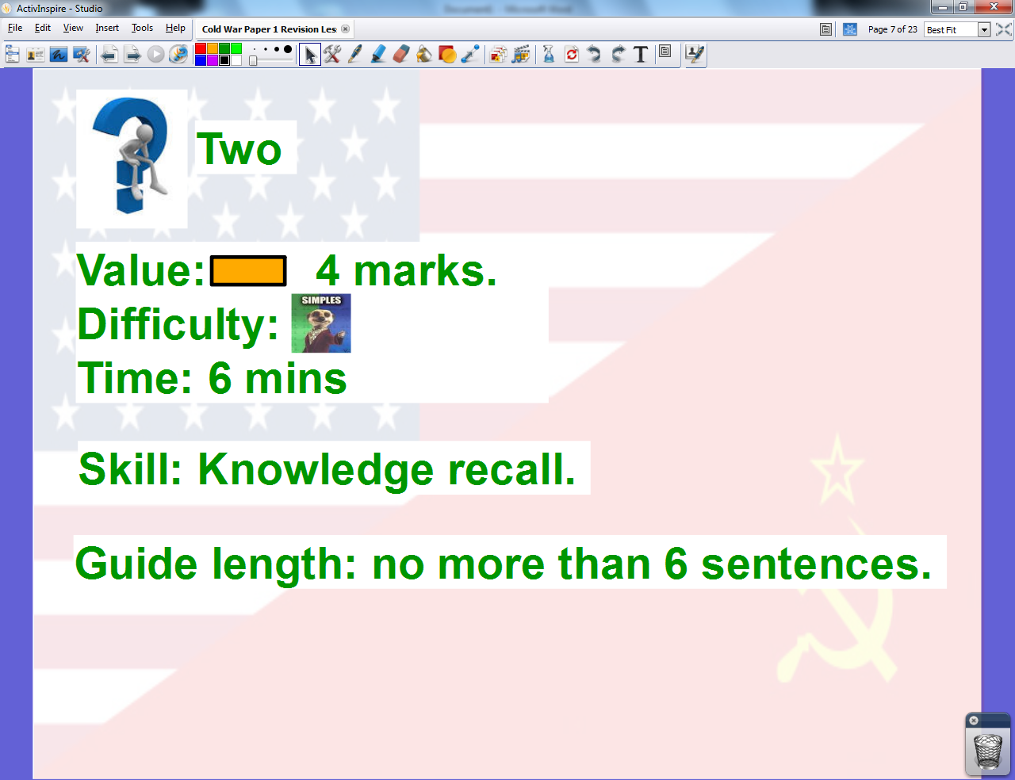

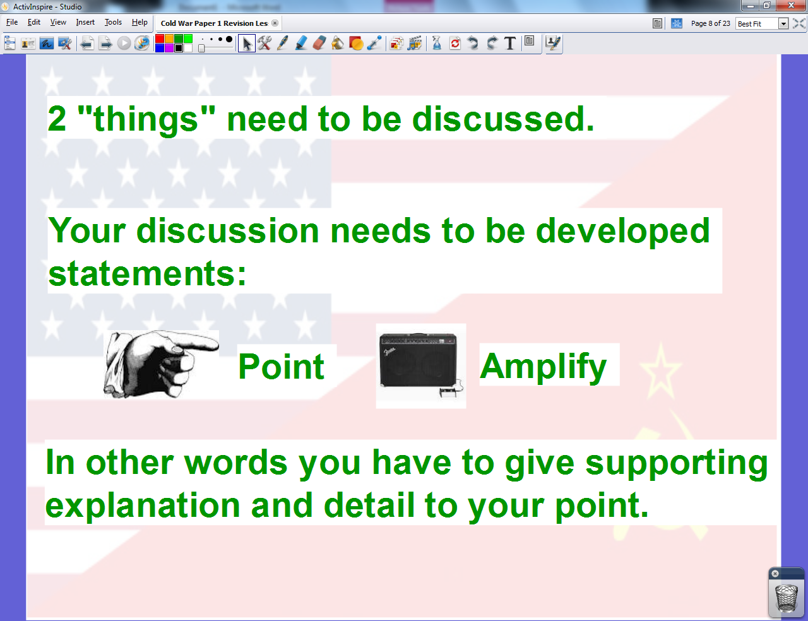

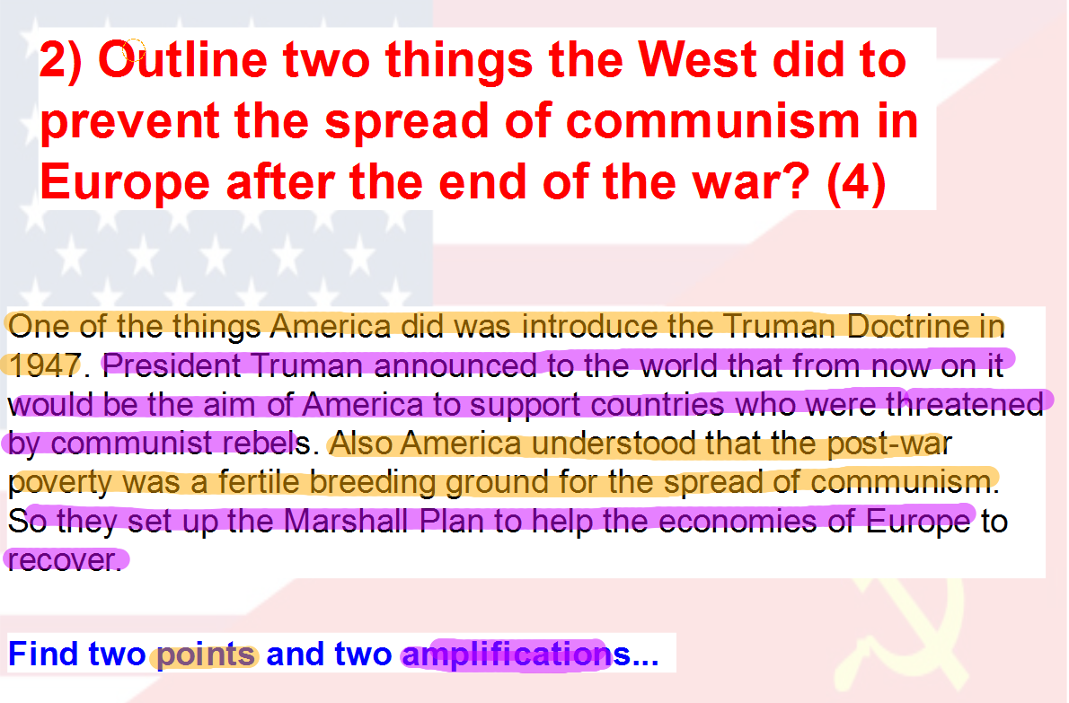
PRACTICE: question 2

- Outline two features of the Helsinki Agreement. (4)

______________________________________________________________________________________________________________________
______________________________________________________________________________________________________________________
______________________________________________________________________________________________________________________
______________________________________________________________________________________________________________________

______________________________________________________________________________________________________________________

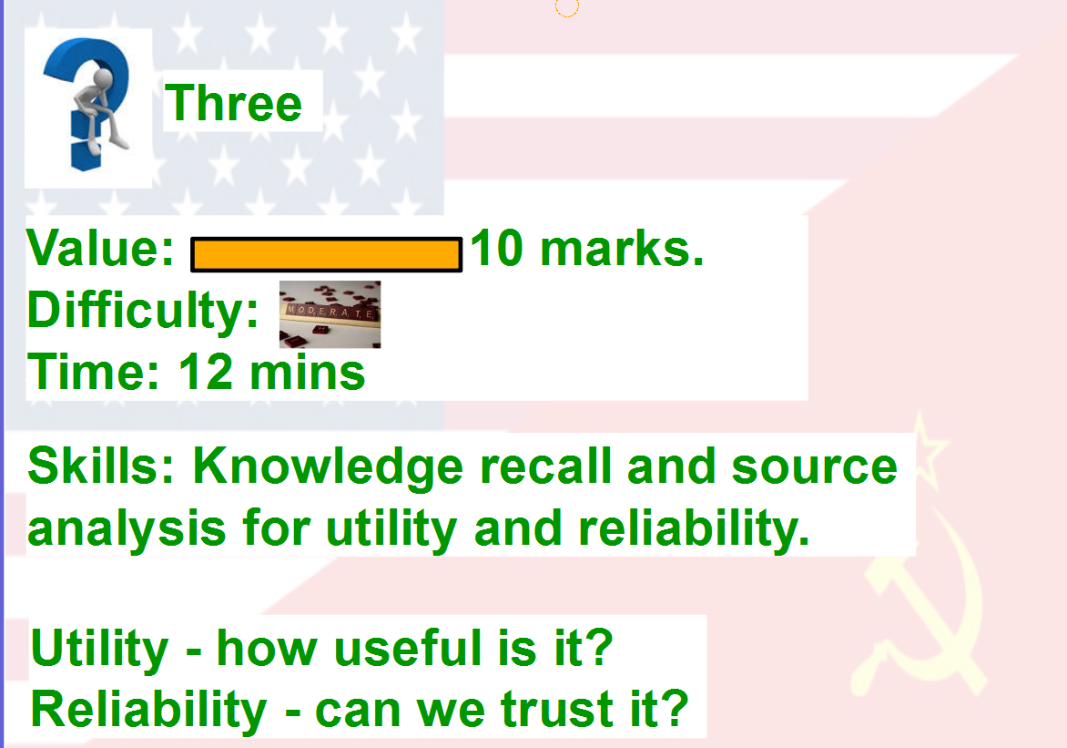

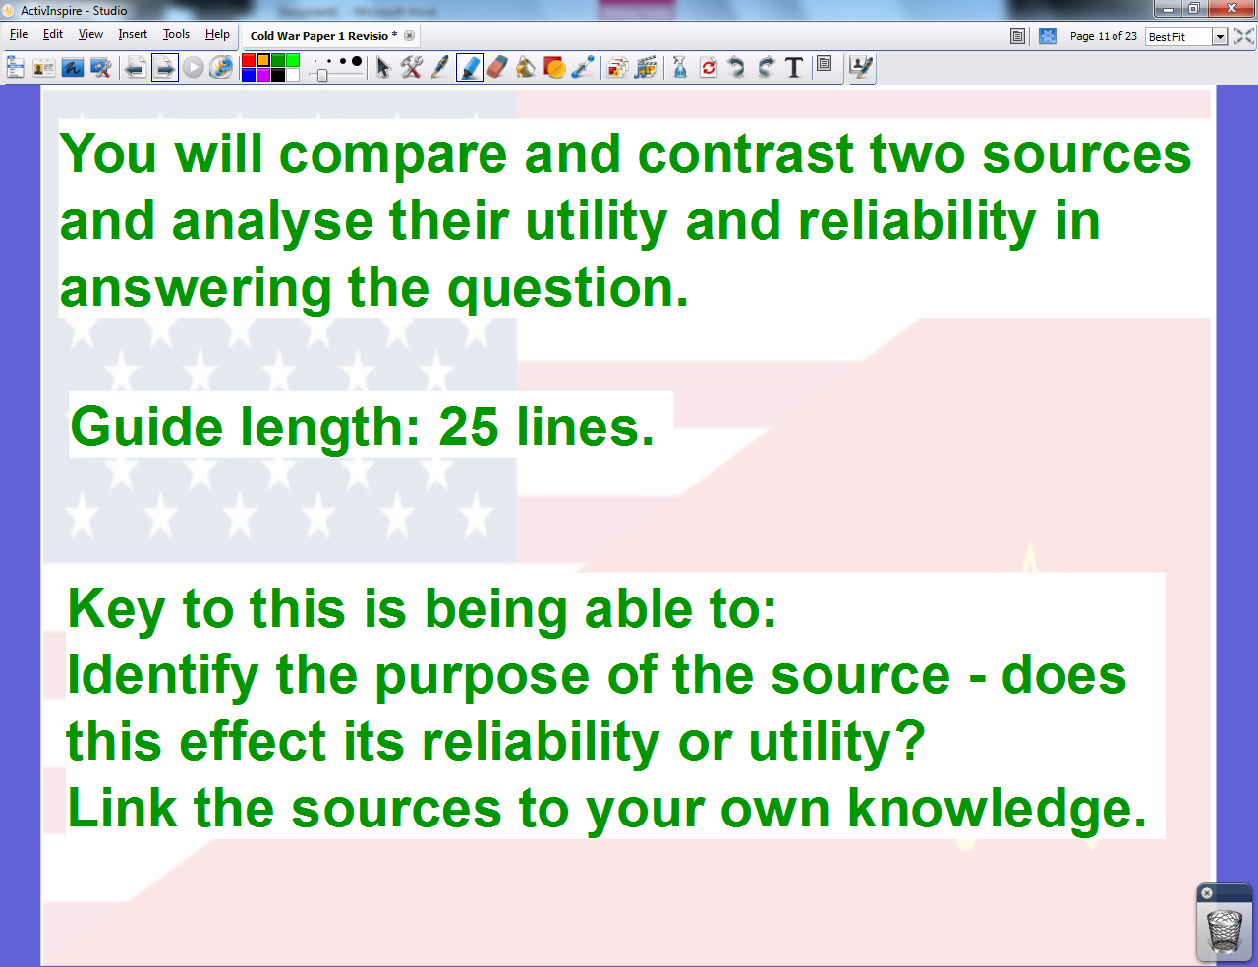

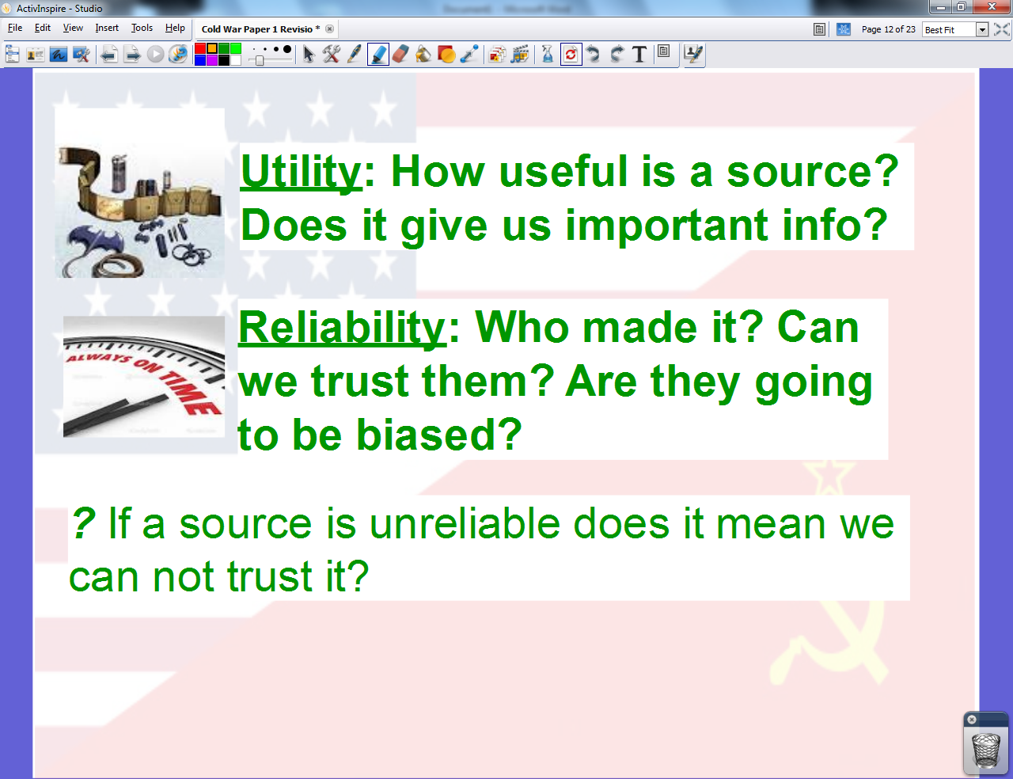

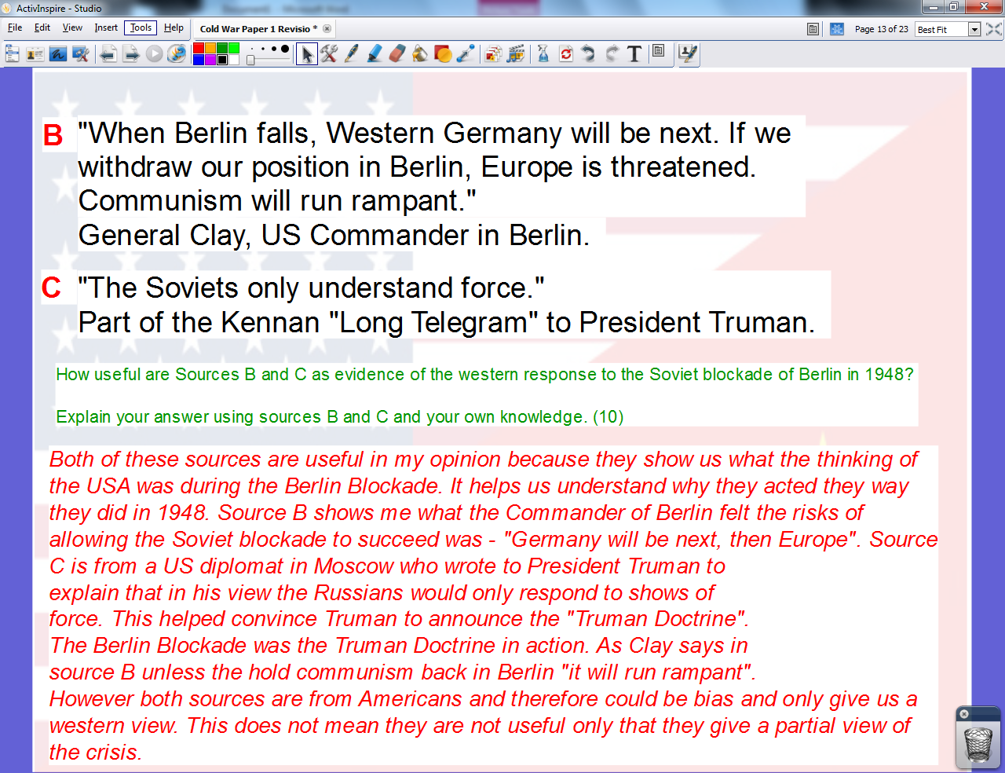

PRACTICE: question 3

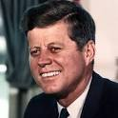
(B) “Democracy may not be perfect but we never had to put up walls to keep our people in.”
JFK 1962.
(C)“In no part of the world are so many spies of foreign states to be found as in West Berlin. Nowhere else can they act with such freedom. These spies are smuggling agents into East Germany causing sabotage and riots.” View of East German Government 1962.
JFK 1962.

- How useful are sources B and C as evidence for the reasons behind building the Berlin Wall in 1961? (10)

______________________________________________________________________________________________________________________
______________________________________________________________________________________________________________________
______________________________________________________________________________________________________________________
______________________________________________________________________________________________________________________

______________________________________________________________________________________________________________________
______________________________________________________________________________________________________________________
______________________________________________________________________________________________________________________
______________________________________________________________________________________________________________________
______________________________________________________________________________________________________________________

______________________________________________________________________________________________________________________
______________________________________________________________________________________________________________________
______________________________________________________________________________________________________________________
______________________________________________________________________________________________________________________
______________________________________________________________________________________________________________________

So youngster did you consider both how useful the sources where as well as whether you could trust them?
Yes…I considered utility and reliability…and linked the sources to my own knowledge!
(Patronising old commie.)

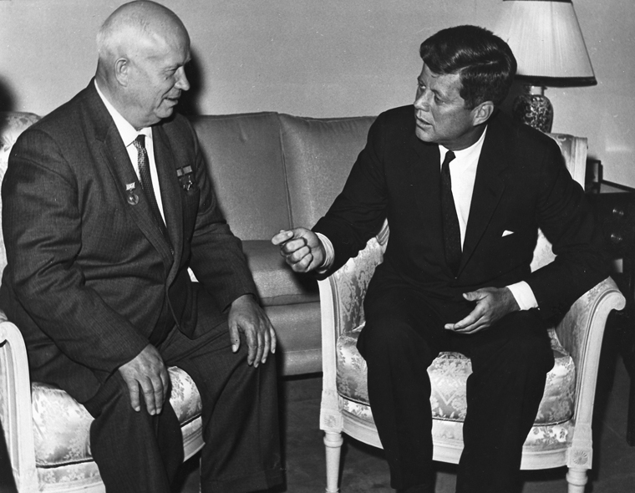

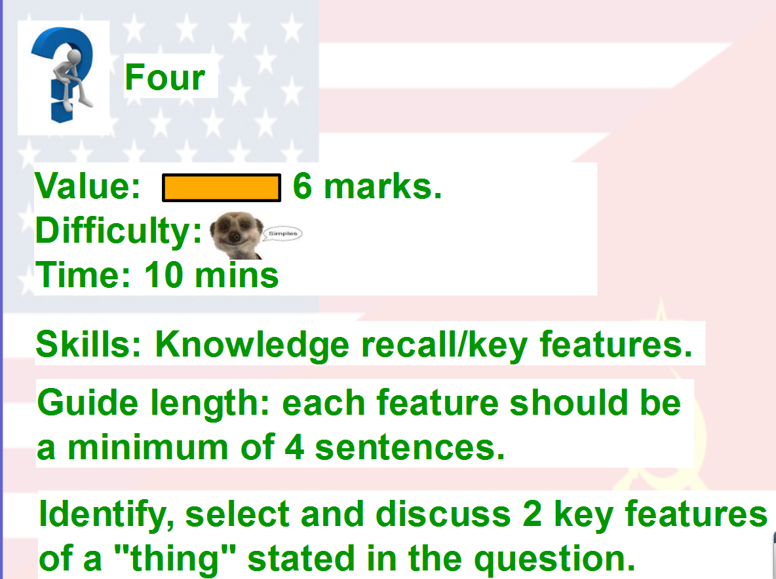

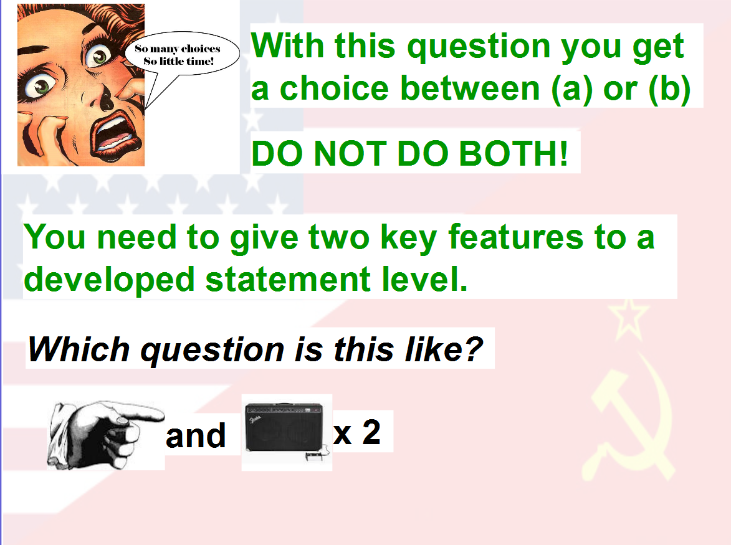
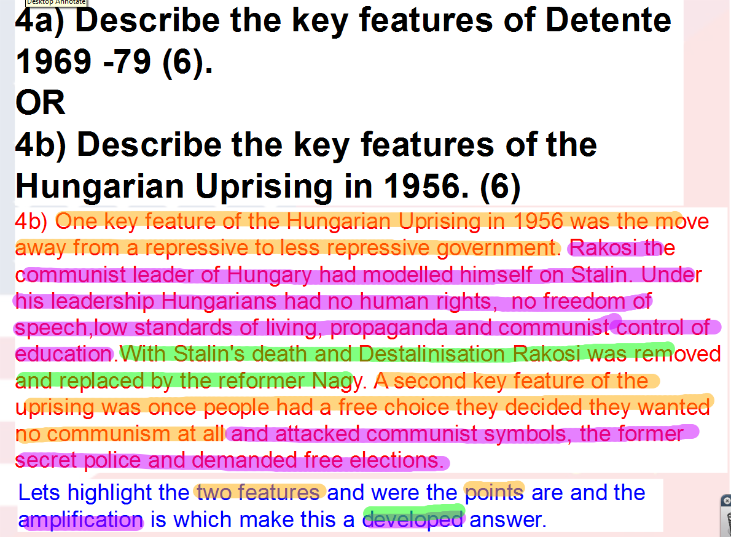
PRACTICE: question 4

4a) Describe the key features of the Prague Spring of 1968. (6)
OR
4b) Describe the key features of Détente 1969 – 79. (6)

______________________________________________________________________________________________________________________
______________________________________________________________________________________________________________________
______________________________________________________________________________________________________________________
______________________________________________________________________________________________________________________

______________________________________________________________________________________________________________________
______________________________________________________________________________________________________________________
______________________________________________________________________________________________________________________
______________________________________________________________________________________________________________________
______________________________________________________________________________________________________________________

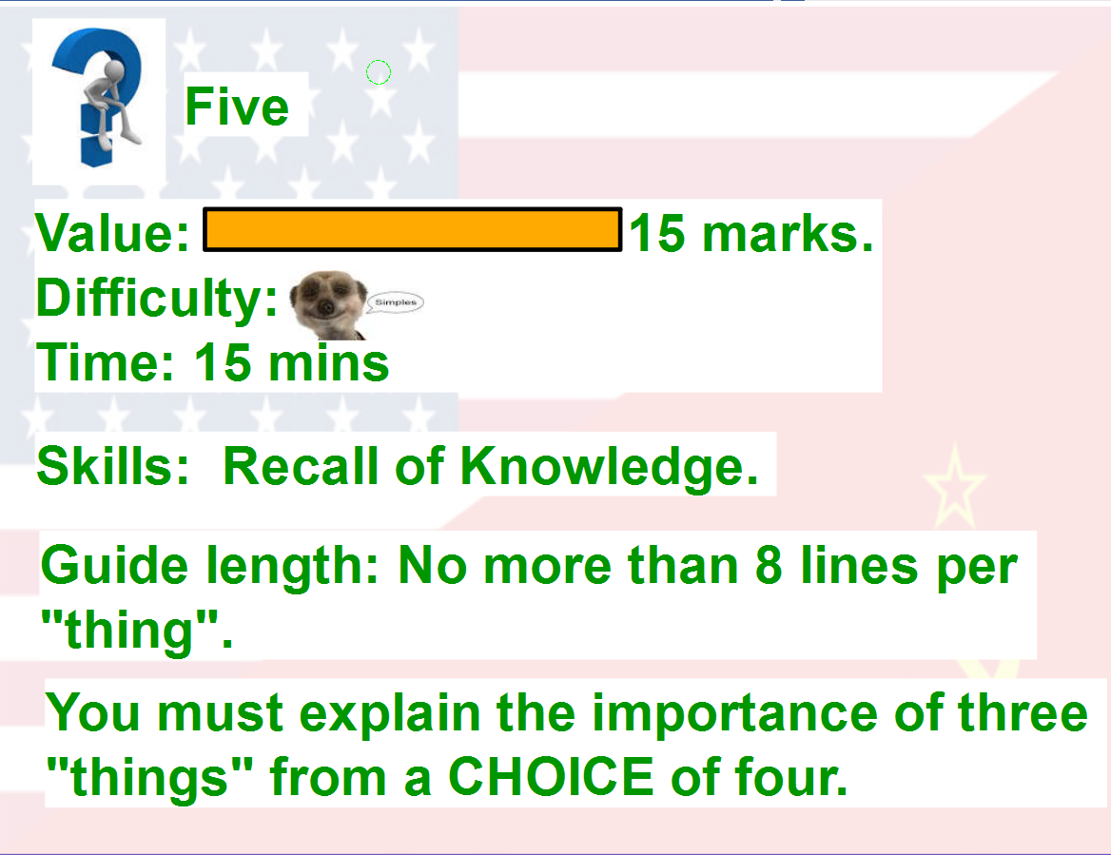

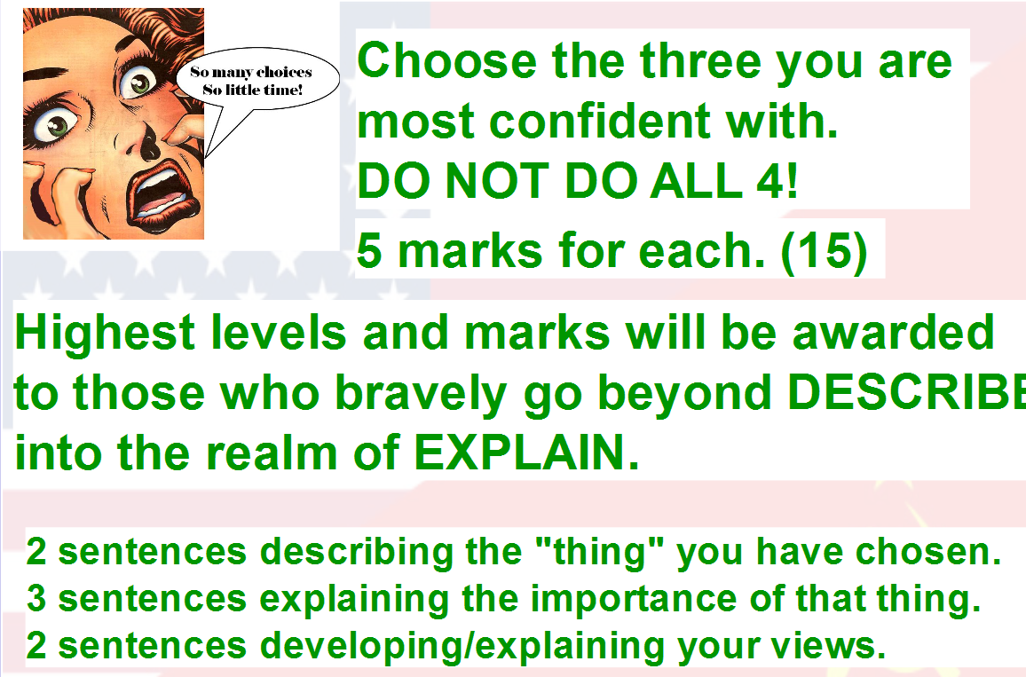
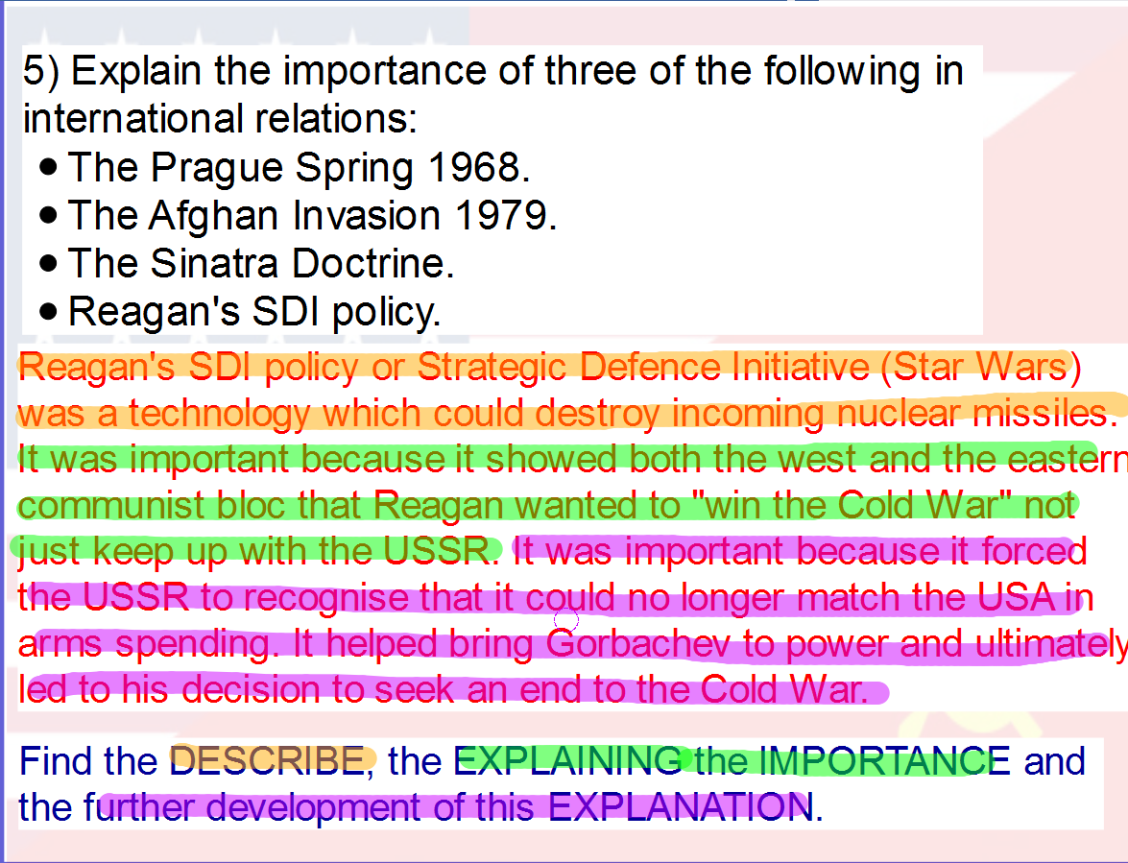
PRACTICE: question 4

- Explain the importance of three of the following in international relations:
- Prague Spring.
- The Afghan Invasion.
- The Sinatra Doctrine.
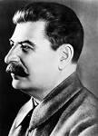
- The Marshall Plan.

(15)
Remember greedy capitalists – ONLY 3!

______________________________________________________________________________________________________________________
______________________________________________________________________________________________________________________
______________________________________________________________________________________________________________________
______________________________________________________________________________________________________________________

______________________________________________________________________________________________________________________
______________________________________________________________________________________________________________________
______________________________________________________________________________________________________________________
______________________________________________________________________________________________________________________
______________________________________________________________________________________________________________________
______________________________________________________________________________________________________________________
______________________________________________________________________________________________________________________
______________________________________________________________________________________________________________________
______________________________________________________________________________________________________________________
______________________________________________________________________________________________________________________

______________________________________________________________________________________________________________________
______________________________________________________________________________________________________________________
______________________________________________________________________________________________________________________
______________________________________________________________________________________________________________________
______________________________________________________________________________________________________________________
______________________________________________________________________________________________________________________
______________________________________________________________________________________________________________________
______________________________________________________________________________________________________________________
______________________________________________________________________________________________________________________
______________________________________________________________________________________________________________________

______________________________________________________________________________________________________________________
______________________________________________________________________________________________________________________
______________________________________________________________________________________________________________________
______________________________________________________________________________________________________________________
______________________________________________________________________________________________________________________

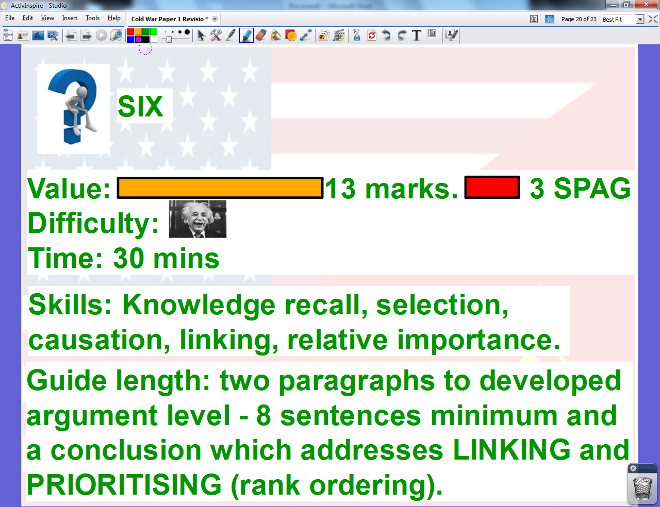
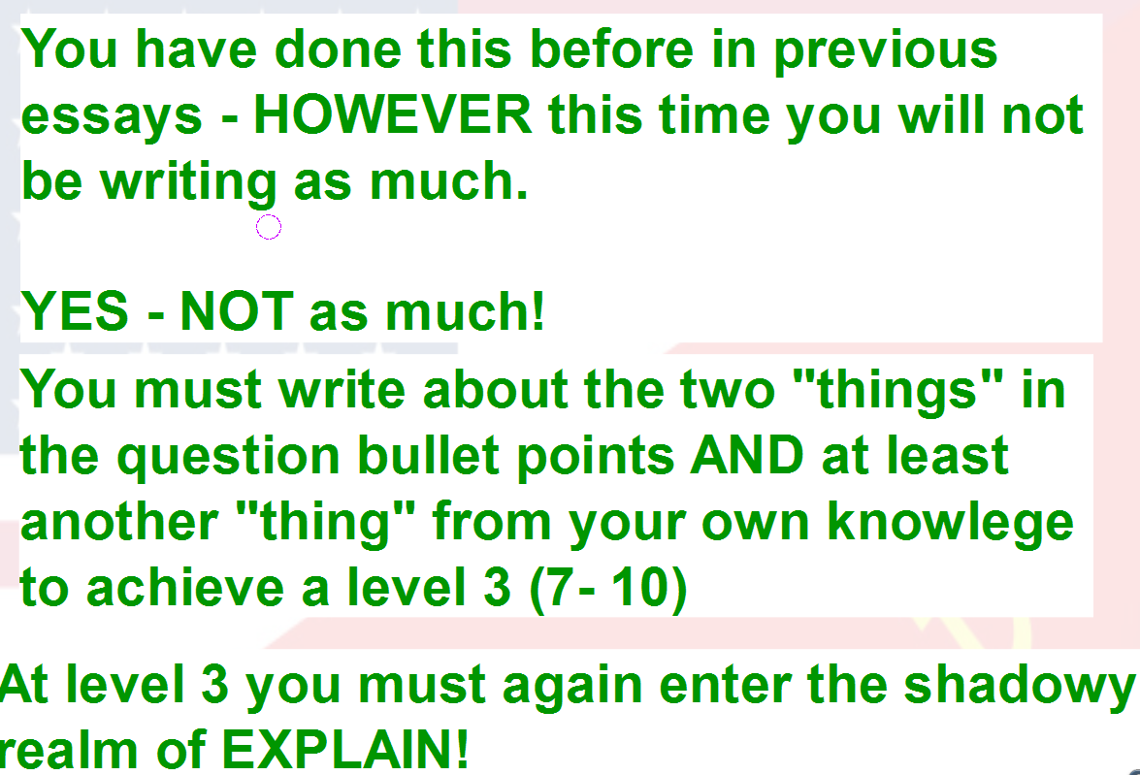

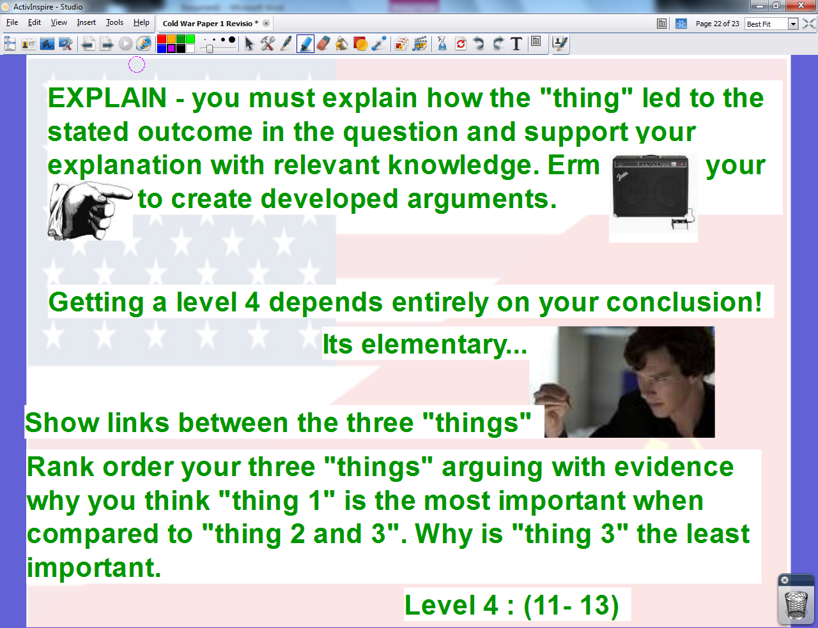

Now go forward bravely Comrades into the glorious pages of revision notes. A new dawn of high grades is within our grasp.
Go on… go.
I SAID GO!

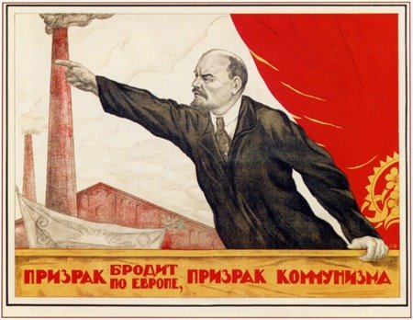
REVISION NOTES ON THE ERA OF THE COLD WAR

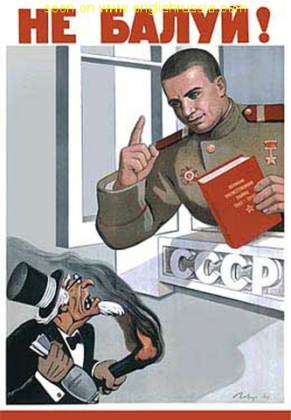
No way Commie! I was planning on doing diddly squat and winging it on the day!
Hey Capitalist Student!
Era of the Cold War – Paper 1
Revision Guide
Time to revise using the revolutionary idea of looking at notes, remembering knowledge, practicing questions and developing skills.

