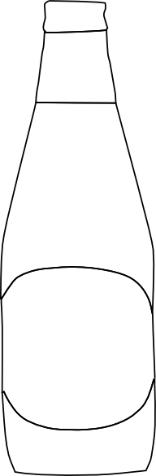

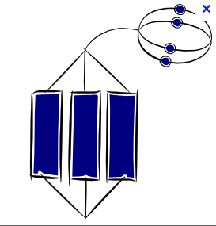







**What would your**

**recommendation to Roosevelt be…?**

**Write how Prohibition**

**increased criminality.**

**List some unexpected outcomes of Prohibition.**

**Write the reasons they were against alcohol.**

**Name groups who were “Drys”**

**What laws introduced**

**Prohibition?**