GCSE History Controlled Assessment
CA8 Crime Policing and Protest - Part B

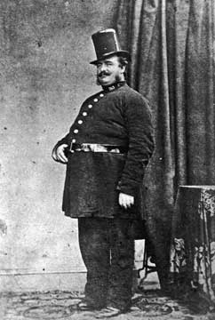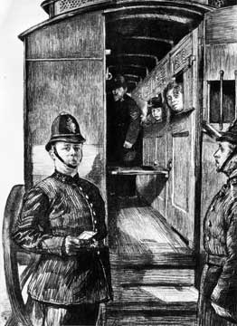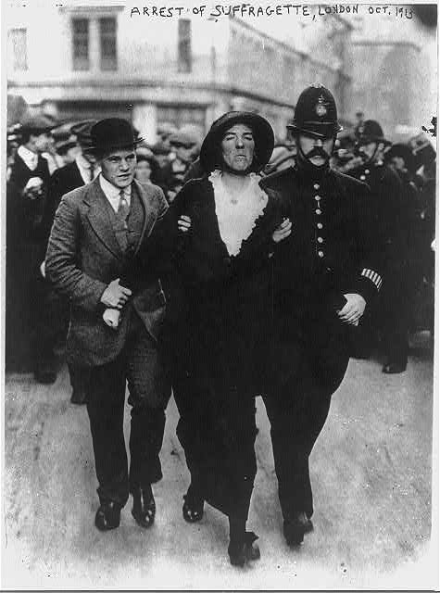

Research and Writing Task

October

How far were the police instruments of repression in the years c1886–1914? (20)

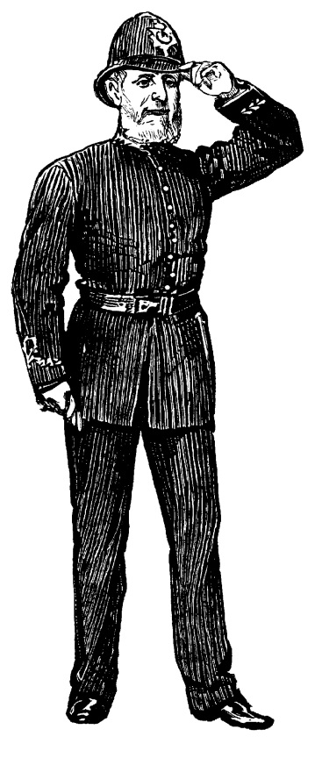
Evening All…In this learning task you will be writing up your draft of Part B of your controlled assessment.

Remember this is worth 20 marks of your final grade.

Use this useful guide to help your understanding of the question, carry out your independent research, apply your learning from class, construct a bibliography and write your initial draft.
yyrr
DEADLINE: for draft 1 of Part B it is:
First History lesson back – week beginning 3rd November.
Room for more inside…
Failure to meet this deadline will lead to a compulsory attendance at the Thursday 3.15pm elective in F19.
The Question:

How far were the police instruments of repression in the years c1886–1914? (20)

How far – this means you have to evaluate! “To what extent”.
Therefore you will have to look at evidence that suggests that the police were instruments of repression and evidence which says they were not. You will have to decide where you think the truth lies and give a balanced view in your conclusion. However it is acceptable to lean one way or the other if you have evidence to support it.

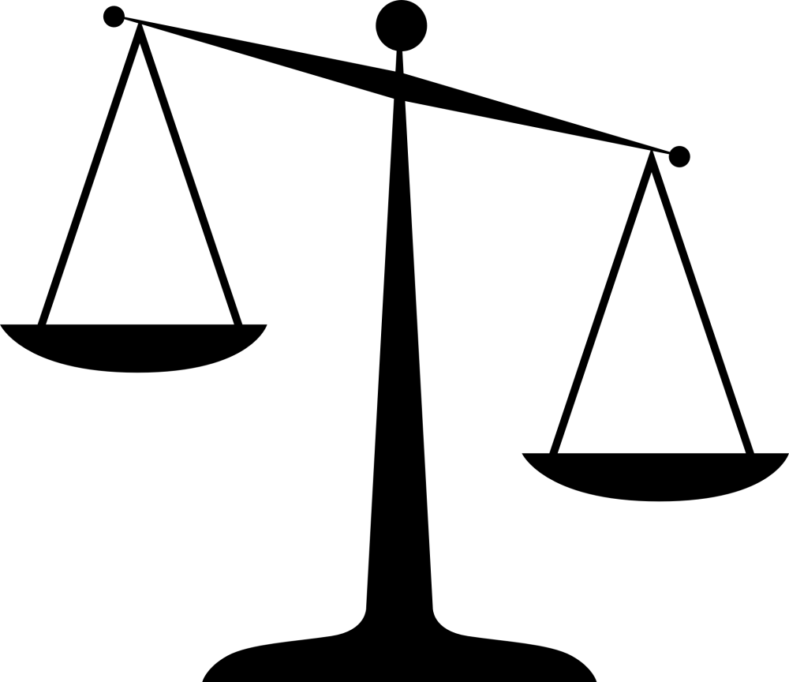
Against
Favour
Supported by evidence
Conclusion

How far were the police instruments of repression in the years c1886–1914? (20)

“Instruments of Repression” – this is what you are evaluating. So you better have a clear idea what it means!
wwww
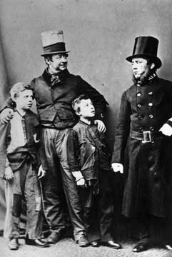
  - Repression:
  - the action of subduing someone or something by force.
"students sparked off events that ended in brutal repression"
synonyms: | suppression, quelling, quashing, subduing, crushing, squashing, stamping out;

Watch it you two rascals or I will repress the life out of you!!!

So the question wants you to consider to what extent the police acted as instruments/tools used by the government to repress the citizens/people of Britain.

You will need to remember the original ideals of the police – 1829 Peelian Principles when judging this.
How far were the police instruments of repression in the years c1886–1914? (20)

“years c1886–1914”

This provides the time period to focus on. You can refer to things outside this period in order to create a context or give explaining background information. BUT focus mainly on events within this 30 year period.

Topic timeline
We have provided the timeline below as an additional resource for students.

1878 Creation of the CID.
1883 Creation of Special Irish Branch of the CID.
1886-87 Trafalgar Square Riots.
1888 The Whitehall Murders.
1900 E R Henry’s The Classification and Use of Fingerprints is published.
1901 Fingerprint branch created at New Scotland Yard.
1903 Women’s Social and Political Union formed by Emmeline Pankhurst and her daughters, Christable and Sylvia.
1906 WSPU members arrested after protest in House of Commons.
1909 Marion Wallace Dunlop went on hunger strike; forced-feeding introduced.
1910 WSPU and ‘Black Friday’ protest.
Dr Crippen hanged for the murder of his wife.
1911 The Siege of Sidney Street.
1913 Cat and Mouse Act.
Death of Emily Davison.
1914 Special Constables Act.

Some of these events you will need to include. Do you know which?

Investigation:

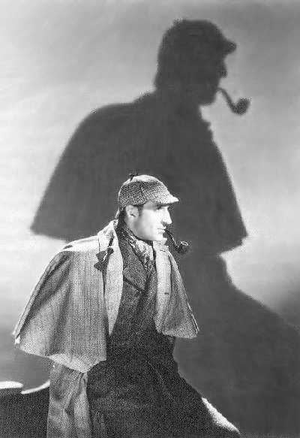
What is a ‘range’ of sources?
● Candidates are expected to use five or more different secondary sources in their Part B enquiry.
● There are no restrictions on the type of secondary sources to be used; they can be textbooks, work by historians, books for the general public, websites, media sources, etc. There is no requirement for students to use different types of secondary sources; it is acceptable for the bibliography to contain only books or only websites. They may also use primary sources in addition to the secondary sources, but these are not required and do not count towards the five sources expected.
● Some secondary representations contemporary to the period studied may also be used. However, the expectation is that ‘sources’ here means sources of information (i.e. works of some kind) rather than simply short extracts or images which are used as sources in Part C.
● An example of an appropriate source of information could be a ‘chapter’ (often one or two double-page spreads) in a GCSE textbook, a web page devoted to the specific topic, a museum display, a television documentary, and so on.
- One of the sources used must have been published or created in the twenty-first
century.
But Holmes what do you mean by a range of sources?

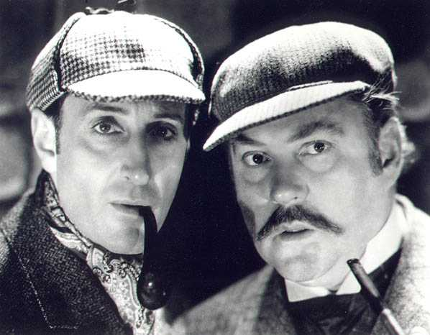
Personal Research!

For part B you need to demonstrate that you have investigated the topic yourself as well as with your teacher.

“Its Elementary my dear student”

You need to show that
- you address the enquiry focus, rather than simply writing everything you know on the topic
- that you have selected and used material from a range of relevant secondary sources (books, websites, etc.).

How do candidates show they have selected and used a range of sources?

● the assessment criteria require explicit referencing within the answer, and marks must be kept to the mark ceilings within levels if students do not do this in their
response to the enquiry question.
● GCSE candidates are not required to reference their sources through footnotes (although this is obviously acceptable), but they should make it clear that they are selecting and deploying information from a range of sources. This might be done through direct comment in the text, for example ‘as Leonard and Whittock say’ or ‘the picture on page XX of Waugh and Wright’. The source can also be named after the specific detail used, for example ‘This happened in 1968 (PBS documentary)’. Because they can prepare a bibliography to bring into the write-up session, candidates could also number the items on their bibliography and then put the number of the relevant work in the margin or in brackets in their essay.

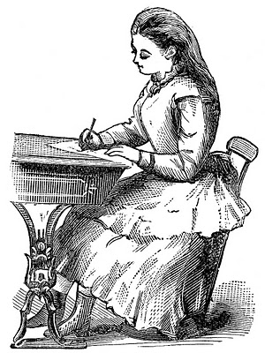

So as I am writing, if I use evidence to support my view or argument I should reference where I got the information from…

“The suffragettes outside Parliament where violently handled by the Police”
(A History of the Suffragettes – Jack Smith, 1987)

Or

“The suffragettes outside Parliament where violently handled by the Police”
(1)
Then make sure entry (1) in my bibliography is A History of the Suffragettes – Jack Smith, 1987

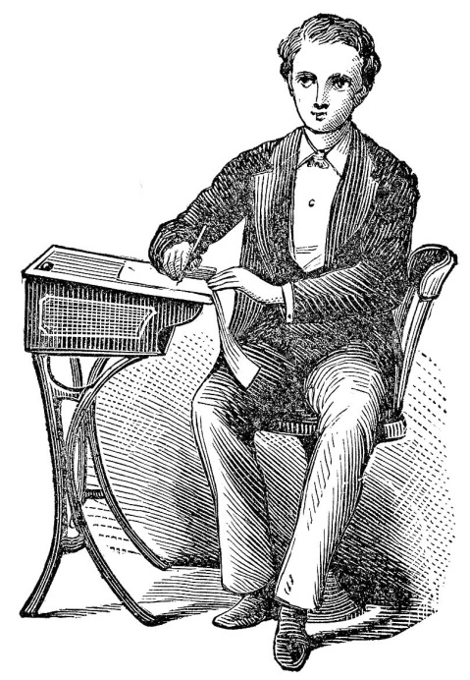
Okay I am ready to start researching but…
where can I find information and what should my bibliography look like?

Suggested resources to support teachers and candidates
The following is a provisional list of resources, which may be useful for this topic.
The following student book was published in 2010 to support the CA8 topic in the 2009 specification. Note it has not been updated for the 2013 specification, so does not include material on protest, but some of the content will still be of use to students.
Edexcel GCSE History: CA8 Crime, Policing and Punishment in England c.1880–c.1990 Controlled Assessment Student Book, ISBN 9781846906466.
Edexcel GCSE History A Unit 3A War and the transformation of British society c1903-28 (Pearson) – contains material on suffragettes and the General Strike
Edexcel GCSE Edexcel GCSE SHP 1B3B Crime and Protest Student Book (Pearson)
GCSE Modern History for Edexcel: War and Transformation of British Society 1903-1928 (Hodder)
Edexcel Crime & Punishment Through Time (Hodder)

The Internet is a useful source of information for this topic.
There are interactive teaching and learning activities on Turning Points in Law and Order at: www.schoolhistory.co.uk/revision/crime.shtml
A detailed chronology of the Metropolitan Police force can be found at: www.met.police.uk/history/index.htm.
The National Archives website has lots of useful resources. www.nationalarchives.gov.uk/education/
The National Archives Cabinet Papers also cover law, liberty and society www.nationalarchives.gov.uk/cabinetpapers/themes/law-liberty-society.htm. They also run a series of workshops on Jack the Ripper www.nationalarchives.gov.uk/documents/education/jacktheripper.pdf.
More resources on Jack the Ripper:
● There is a thorough examination of Jack the Ripper on: www.bbc.co.uk/history/historic_figures/ripper_jack_the.shtml
● There is also the 1998 film Jack the Ripper.
● There are full details of cases attributed to Jack the Ripper at: www.casebook.org.
● There is also a section on the Metropolitan Police History website: http://content.met.police.uk/Site/jacktheripper.
● Jack the Ripper walks are arranged by: www.jack-the-ripper-walk.co.uk and www.jack-the-ripper-tour.com.

Dr Crippen:
● http://content.met.police.uk/Article/Dr-Crippen/1400015339071/historicalcases
● http://drcrippen.co.uk/index.html

Suffragettes:
• The Public Records Office has many resources about the activities of the WSPU: www.nationalarchives.gov.uk/education/britain1906to1918/pdf/complete_g4.pdf
• There is a section on parliament’s website about women’s campaigns to gain the vote: www.parliament.uk/about/living-heritage/transformingsociety/electionsvoting/womenvote/
• The Spartacus websites contains both information and primary sources:www.spartacus.schoolnet.co.uk/Wwspu.htm
There are links to useful website links on our School History website.

This list is also an example of what a
bibliography should look like.
An outline cunning plan:

Have you referenced your quotes and evidence to the sources you took them from? Have you linked them to your bibliography? Have you created a bibliography?

Conclusion:

Weigh up the evidence.
Is there more for one side or the other?
Make a clear judgement and answer the question.
Summarise your points linking back to discussion in your essay – like a lawyer would do in court.
1913 – Cat and Mouse Act

Evaluate – is it good policing? Repressing political protest or maintaining order?
1910 – WSPU Protest – Black Friday.

Evaluate – focusing on the question and linking back to Peelian Principles.
1907 March on Parliament – evaluate this march using the material we studied in class.
Any other suffragette militant action you can evaluate?
Any other militant action in 1906?
25 April 1906 – WSPU
(Suffragettes) arrests for disturbing political meeting in the House of Commons – evaluate.
Link back to this.
The creation of the suffragettes – why were they militant?
What potential problem will this create for police?
First case study – the Trafalgar Square Riots 1886-7. What happened?
Evaluate the police actions in relation to the question.
How might the police clash with issues around democratic rights in Britain? Policing public order…
Introduction – use this paragraph to discuss the Peelian Principles that were used to set out the future behaviour of the British Police.

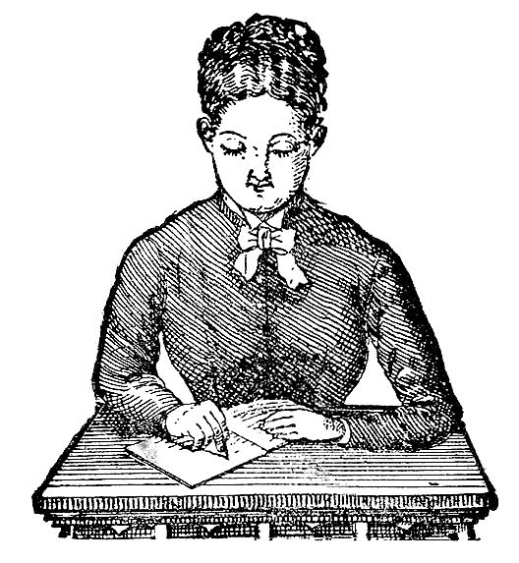

Final Checklist:

In this part of the assessment, you will be successful if you:
● focus on the enquiry. (Write about what the question is asking.)
● use good spelling, punctuation and grammar and communicate clearly.
● show that you have selected sources of information carefully.
● use information from your sources to back up the points you want to make and make it clear which source you have used to find that information. At least one of your sources
of information must have been created in the twenty-first century.
● organise your points so that your answer leads to your conclusion.
● show that you are aware of different views or emphases within sources.
● at the end of your answer, sum up the reasons why you came to your conclusion in the enquiry.

