**GCSE History**

**Unit 4: Britain 1950-79**

**Education 1960-79**

[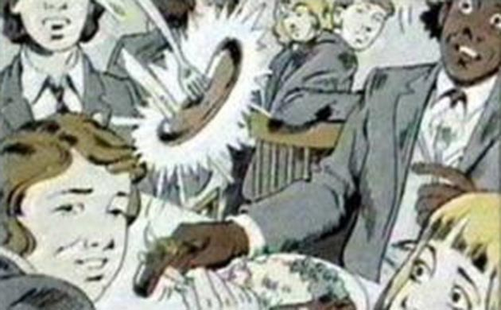](http://www.theguardian.com/media/gallery/2008/feb/06/bbc.television#img-2)

**Student Flipped Learning Booklet**

**In this booklet you will explore:**

* The different experiences of education in the 1950s Tri-partite system and the progressive Comprehensive education system.
* Arguments for and against the Comprehensive System.
* The challenge of “progressive” ideas in education.
* The impact of educational changes on pupils.

The booklet will contain much of what you need to complete the learning activities, SOLO tasks and practice exam questions, however there will be links to take you to online resources which you will also have to use.

**Introduction:**

**So what is the point of education!?**

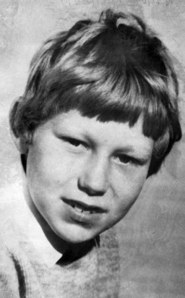

Education was and remains a highly controversial topic which divides opinion:

Should schools be traditional institutions that promote discipline and the learning of facts or should they be more progressive and promote key skills like group work and independent learning?

Above all parents, politicians and students themselves argue about education’s main purpose: should it promote competition and maximise individual progress or should it promote cooperation and greater social equality?

[](http://www.google.co.uk/url?q=https://twitter.com/flippedlearning&sa=U&ei=h1C-VNKQFszUatHGgrAH&ved=0CCYQ9QEwCDgU&sig2=v0qZlUDL8YW5-KtqeZllwg&usg=AFQjCNEdvhSGhyi41txQaXiZVMZDr8g-ig)

1. Think about your views on the purpose of education. Watch the video on the website to help stimulate your thinking. Record your views. You will have a task to do in class.

**The end of the Grammar School?**

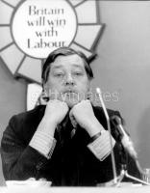

**In 1965 Anthony Crosland the Labour Minister for Education published “Circular 10/65”. This document called for the end of the Tri-Partite education system and its replacement with a new “Comprehensive” system.**

Crosland 1965

Support for Comprehensive schools continued to build throughout the 1960s and 1970s. Teachers, unions and middle class parents (who in particular were worried that their children would end up in Secondary Modern schools if they failed their 11+)were particularly loud in their support for Comprehensive reform.

The Labour Party continued to support comprehensive education throughout the 1970s. The 1976 Education Act removed selection of pupils for schools by exam or any other means.

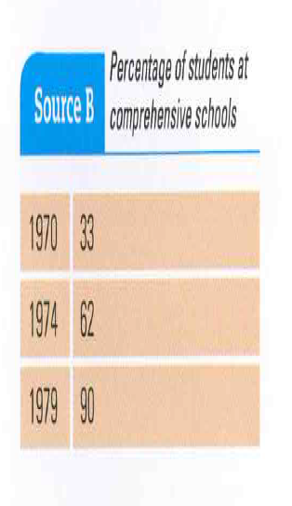

[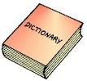](http://www.google.co.uk/url?q=http://www.eslstation.net/ESL310L/310L_dict.htm&sa=U&ei=Cmu-VJDqBcLwaqe7gdAD&ved=0CCwQ9QEwCw&sig2=_hdJGTzVh_5SR3CoH12Sgw&usg=AFQjCNFCaQlNdgELeXlr7XtIlt4YOek9dQ)**comprehensive education/system**

SES **a system of education in Britain in which children of different abilities go to the same school and are taught together**

[](http://www.google.co.uk/url?q=https://twitter.com/flippedlearning&sa=U&ei=h1C-VNKQFszUatHGgrAH&ved=0CCYQ9QEwCDgU&sig2=v0qZlUDL8YW5-KtqeZllwg&usg=AFQjCNEdvhSGhyi41txQaXiZVMZDr8g-ig)

1. Think about arguments in favour of comprehensive schools and arguments against. Use the website links to articles on this debate on the History site to support your thinking. You will be given a task on these arguments in class.

**Two Views on Grammar V Comprehensive:**

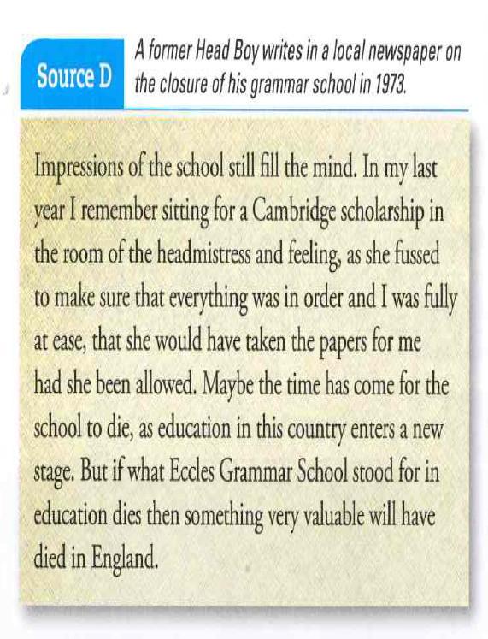

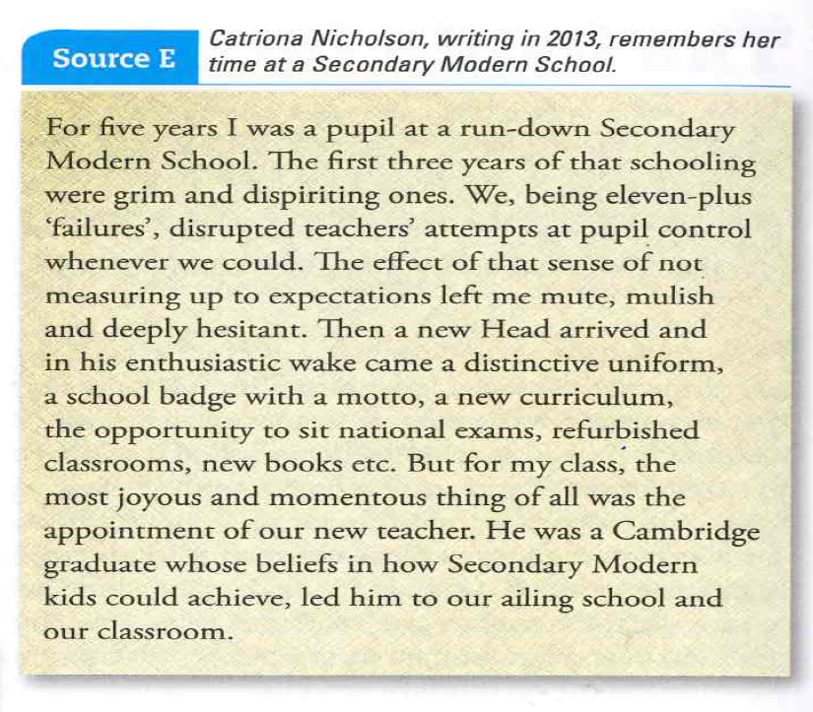

[](http://www.google.co.uk/url?q=https://twitter.com/flippedlearning&sa=U&ei=h1C-VNKQFszUatHGgrAH&ved=0CCYQ9QEwCDgU&sig2=v0qZlUDL8YW5-KtqeZllwg&usg=AFQjCNEdvhSGhyi41txQaXiZVMZDr8g-ig)

1. Read the views expressed in sources D and E. Think about why the author of source D might support Grammar schools and the author of source E might oppose them. Identify reasons given for their views, highlight or annotate quotes from the sources which show these views. Can you link any of their viewpoints to arguments you have identified from Flip activity 2.

You will carry out a SOLO activity on this topic.



***Evaluating* the *Reliability* of Sources**

**How reliable are sources D and E as evidence of pupil’s experience of education in England before the comprehensive reforms?**

**Progressive Education:**

Local Education Authorities (LEAs) did not have the power to control head teachers who wanted to try different teaching methods in their schools. As a result there were sometimes large variations in the way pupils were being taught at different schools.

Many teachers began to introduce progressive methods championed in the **1967 Plowden Report.**

**[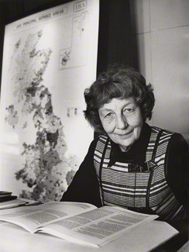](http://www.npg.org.uk/collections/search/portraitLarge/mw80342/Bridget-Horatia-ne-Richmond-Lady-Plowden)Lady Plowden 1967.**

**“Schools need to allow individual children to be themselves and develop in a way and at a speed that suits them…”**

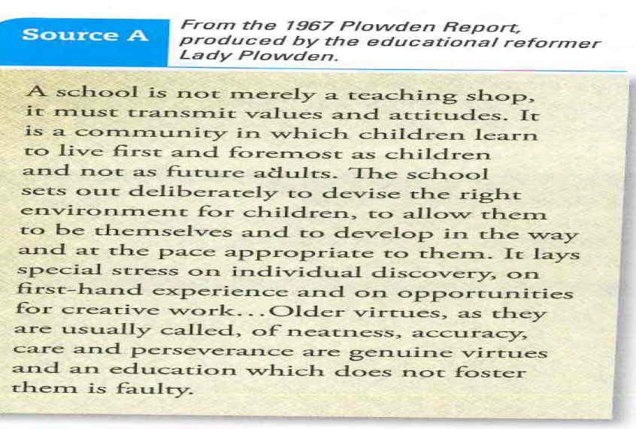

[](http://www.google.co.uk/url?q=https://twitter.com/flippedlearning&sa=U&ei=h1C-VNKQFszUatHGgrAH&ved=0CCYQ9QEwCDgU&sig2=v0qZlUDL8YW5-KtqeZllwg&usg=AFQjCNEdvhSGhyi41txQaXiZVMZDr8g-ig)

**4. Watch the music video on the website. Think carefully about the images, song title and lyrics. Can you find any links between the central message of Pink Floyd's song and the central message of Lady Plowden's report from 1967?**

**The Impact on Pupils:**

**At some schools especially in inner London some progressive teachers took the reforms to the extreme; they introduced relaxed discipline, teachers were called by their first names and there was no uniform.**

**Some parents and right wing papers began to criticise “trendy teachers” and a lack of learning and discipline in the classroom. Some of these genuine fears were made worse by sensationalist newspaper stories and the harsh depiction of life in a Comprehensive School in the hit TV series “Grange Hill” first shown in 1978.**

[](http://www.google.co.uk/url?q=https://twitter.com/flippedlearning&sa=U&ei=h1C-VNKQFszUatHGgrAH&ved=0CCYQ9QEwCDgU&sig2=v0qZlUDL8YW5-KtqeZllwg&usg=AFQjCNEdvhSGhyi41txQaXiZVMZDr8g-ig)

**5. Use the links on the website to read about what happened at William Tyndale Junior School in 1975. Then watch episode 1 of Grange Hill from 1978. Why might enemies of comprehensive progressive education use these as evidence of its dangers?**



**So what was the impact on us 1970s kids…?!**

* **CSE exams were introduced after 1965 this allowed more subjects to be studied and more students to leave school with qualifications.**
* **Top 20% of students did O level exams – so streaming still happened. Employers quickly saw CSEs as second class exams.**
* **1972 Education Act raised the school leaving age to 16 from 15. It also allowed some schools to arrange work experience in this final year and this helped many students find work at a time of economic hardship.**
* **More pupils went to University up from 5% in 1960 to 9% in 1970. But this had a lot to do with increased government funding for University places.**
* **Students from different social and cultural backgrounds did mix together.**

**Assessment!!**

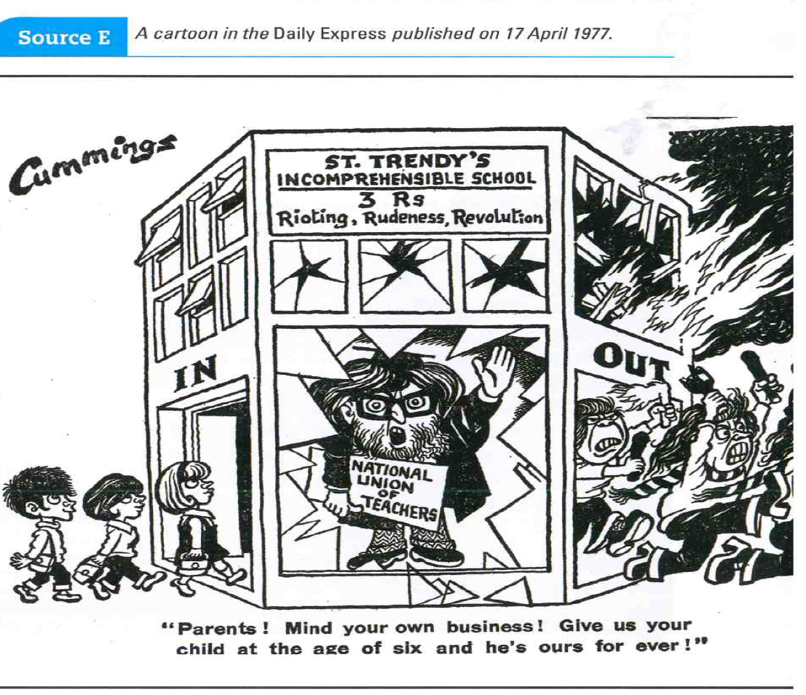

**Examine the cartoon in source E.**

**To what extent does the evidence support Cummings’ view of progressive education.**

**Use this booklet, the information on the website and your own research to explain your view. (16)**