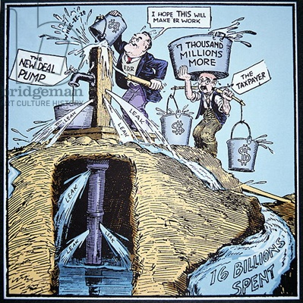

**The Alphabet Agencies:**

**Who Opposed the New Deal?**

**Effects of the Depression:**

**Explanation of Pump Priming and how it links to the Cycle of Recovery:**