Information Sheet 1:
At 3:00 P.M. on April 15,1920, a paymaster and his guard were carrying a factory payroll of $15,776 through the main street of South Braintree, Massachusetts, a small industrial town south of Boston. Two men standing by a fence suddenly pulled out guns and fired on them. The gunmen snatched up the cash boxes dropped by the mortally wounded pair and jumped into a waiting automobile. The bandit gang, numbering four or five in all, sped away, eluding their pursuers. At first this brutal murder and robbery, not uncommon in post-World War I America, aroused only local interest.
Three weeks later, on the evening of May 5, 1920, two Italians, Nicola Sacco and Bartolomeo Vanzetti, fell into a police trap that had been set for a suspect in the Braintree crime. Although originally not under
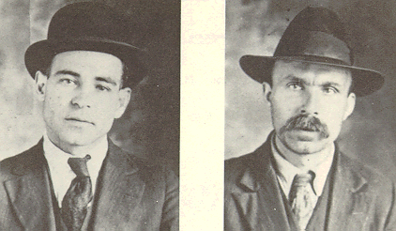
Sacco & Vanzetti
suspicion, both men were carrying guns at the time of their arrest and when questioned by the authorities they lied. As a result they were held and eventually indicted for the South Braintree crimes. Vanzetti was also charged with an earlier holdup attempt that had taken place on December 24, 1919, in the nearby town of Bridgewater. These events were to mark the beginning of twentieth-century America's most notorious political trial.

Information sheet 2
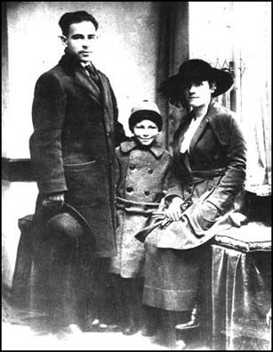
Sacco and his family having their photograph taken in Boston on the day of the robbery – miles from crime scene.

Information sheet 3
Vanzetti and Sacco were disadvantaged by not having a full grasp of the English language. Webster Thayer, the judge was clearly prejudiced against anarchists. The previous year, he rebuked a jury for acquitting anarchist Sergie Zuboff of violating the criminal anarchy law. It was clear from some of the answers Vanzetti and Sacco gave in court that they had misunderstood the question. During the trial the prosecution emphasized the men's radical political beliefs. Vanzetti and Sacco were also accused of unpatriotic behaviour by fleeing to Mexico during the First World War.

Information sheet 4
The main evidence against the men was that they were both carrying a gun when arrested. Some people who saw the crime taking place identified Bartolomeo Vanzetti and Nicola Sacco as the robbers

