**What board games have you played?**

**Is there a game you could adapt?**

**Can you create your own game?**

President Kennedy is young and confident. Move forward 3.

You lose your U2 Spy Plane

go back to START.

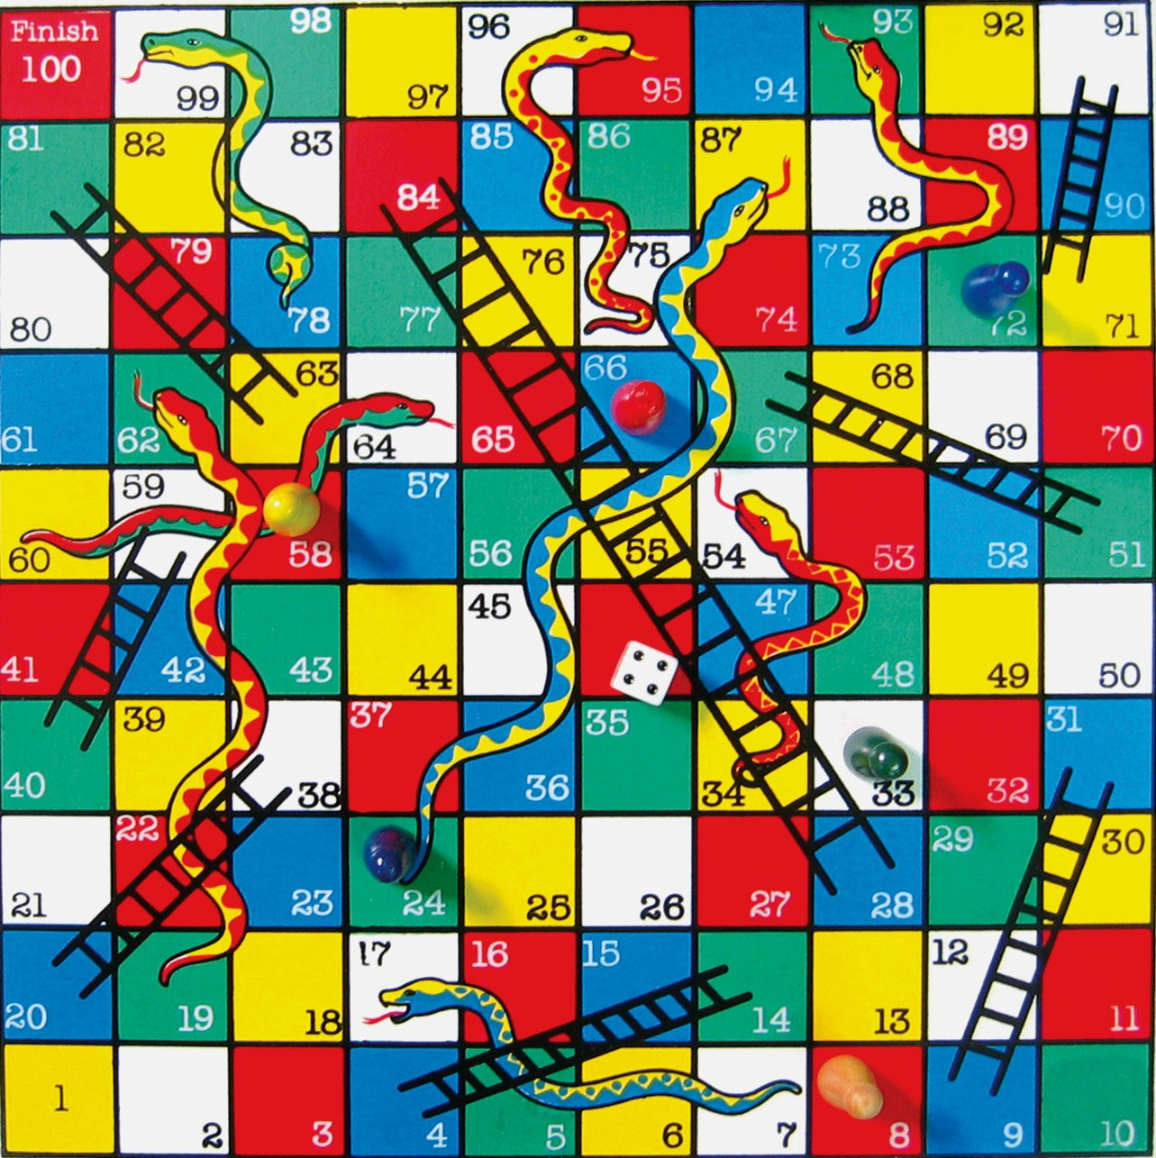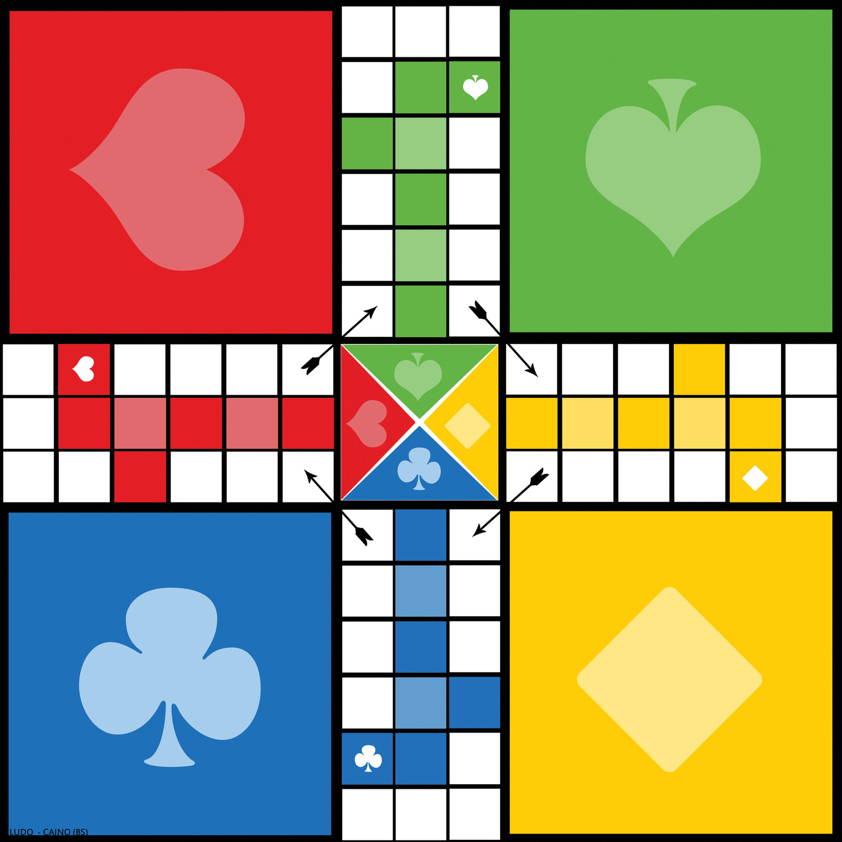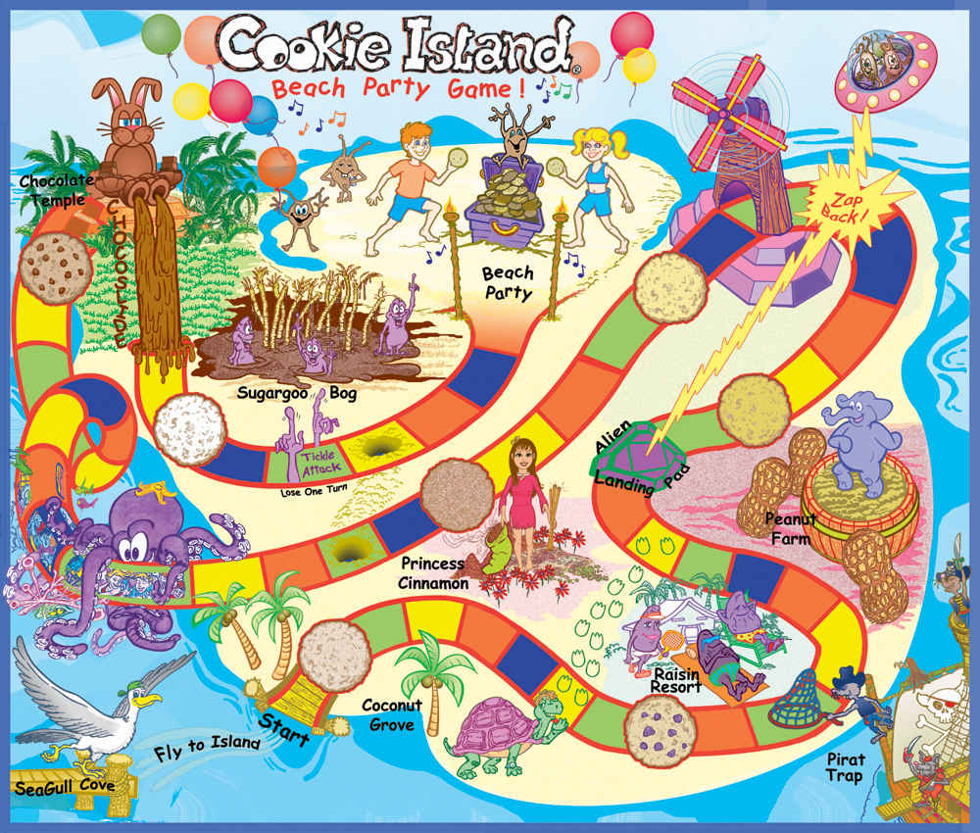[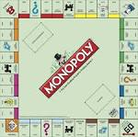](http://www.google.co.uk/imgres?imgurl=http://buskerunderthebridge.com/wp-content/uploads/2013/02/monopoly-board-web.jpg&imgrefurl=http://buskerunderthebridge.com/tag/monopoly/&usg=__3_DV9VaSsqYUIBdqxQdD03ZbtVs=&h=2928&w=2940&sz=612&hl=en&start=1&zoom=1&tbnid=_aT_eBnLy9HRxM:&tbnh=149&tbnw=150&ei=p5N7UriROM24hAfSvIHYDQ&prev=/search?q%3Dmonopoly%26safe%3Dvss%26biw%3D1400%26bih%3D826%26sout%3D1%26tbm%3Disch&itbs=1&sa=X&ved=0CCwQrQMwAA)

WHO will gain ultimate control of Berlin?

Will it be YOU?!

**You need to create a game that uses the crisis over Berlin and the attempts to solve it as the inspiration for a family board game.**

**Time allowed:**

**You will have two lessons to design, create and complete your board game.**

**However you should use some of your own time to work on aspects of this challenge in order to complete it to the best of your ability.**

**Bring things in from home for example to use in class.**



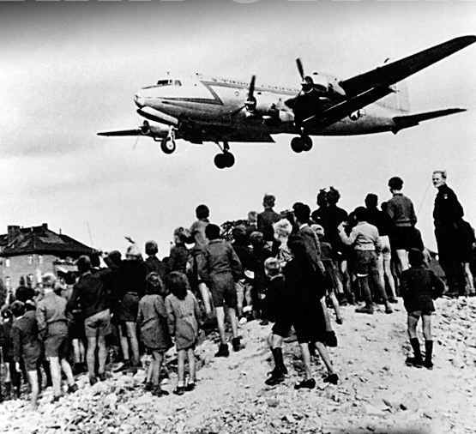

Success Criteria:

The game must reflect the learning you have explored the Berlin Crisis 1950 – 1961.

It must use specific real historical events as part of the game from this period.

The game should be **FUN** but also reinforce and strengthen the players understanding of this period.

The **GOAL** of the game is to secure control of Berlin.

**It must have :**

* a playing board
* a set of instructions for playing and winning the game.
* a set of playing counters.
* additional playing cards if necessary.

**.**

**Your group should be no bigger than a maximum**  **of:**

[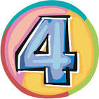](http://www.google.co.uk/imgres?imgurl=http://3.bp.blogspot.com/-9cSZuRMO65M/UOYn20oxGUI/AAAAAAAALgg/zTyw-uLPkO8/s1600/number4.jpg&imgrefurl=http://www.katiesbookblog.com/2013/01/4-years.html&usg=__xskPi7B3NTNy6nsHrnErJVQBGkI=&h=745&w=750&sz=144&hl=en&start=1&zoom=1&tbnid=1N7NeGuMIKZTjM:&tbnh=140&tbnw=141&ei=yXd7Uui5I-iN7Ab3mIDgAQ&prev=/search?q%3D4%26safe%3Dvss%26biw%3D1280%26bih%3D800%26sout%3D1%26tbm%3Disch&itbs=1&sa=X&ved=0CCwQrQMwAA)

