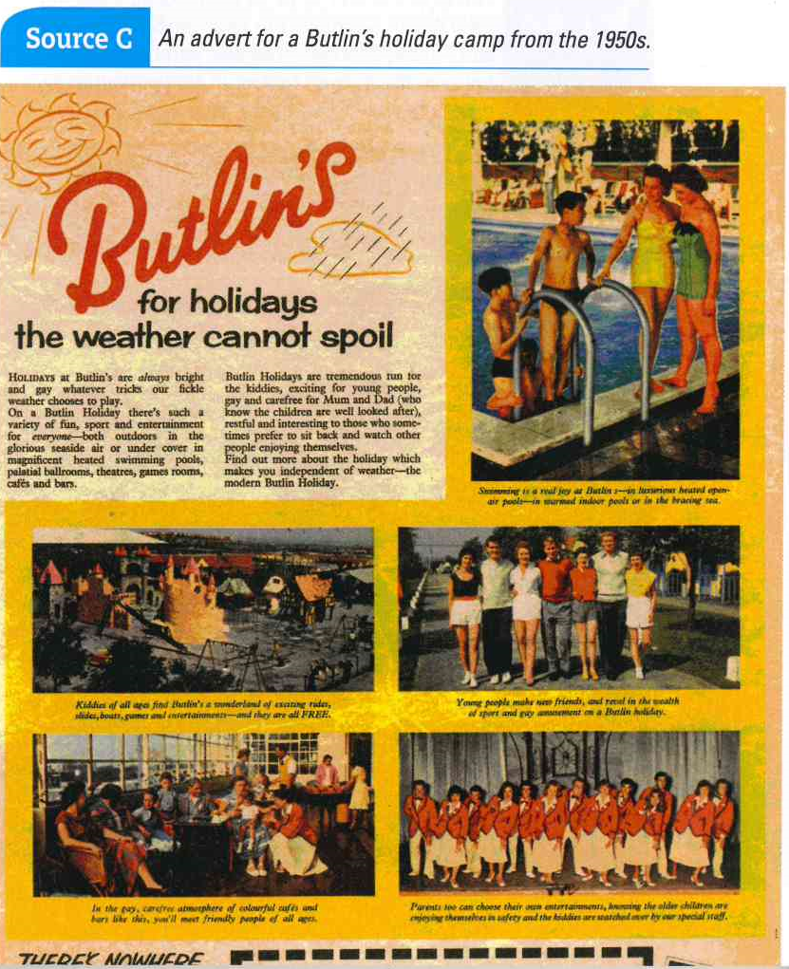







Give several reasons why this advert was produced supported by the source and linked to your own knowledge:

Give one reason why this advert was produced supported by the source or your own knowledge:

Give one reason why this advert was produced.