[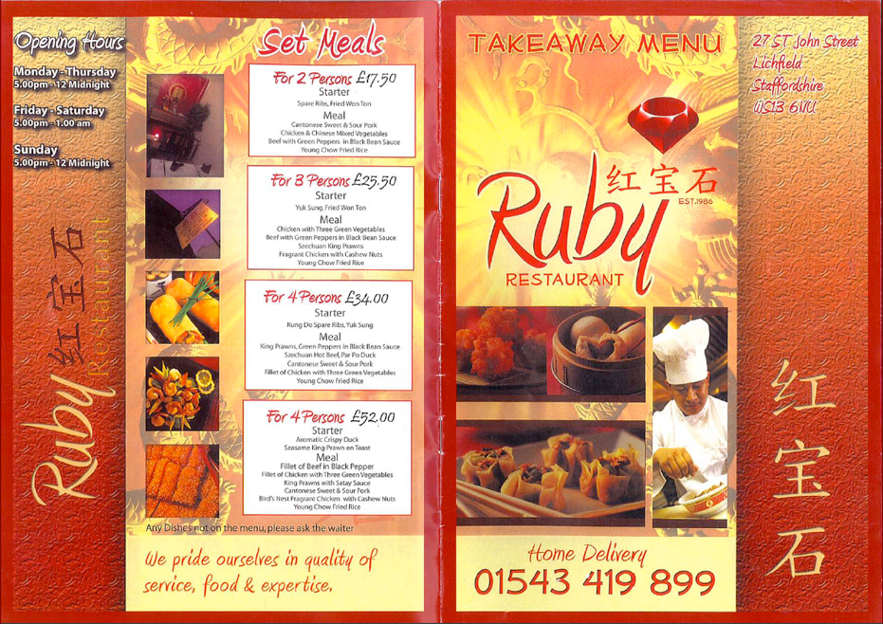](http://www.rubychineserestaurant.co.uk/wp-content/uploads/2012/06/TakeAwayMenu.pdf)

**Choose an item from the set meals and an item from the right hand side of the menu. (2 in total)**

**What would you argue was the most important cause of post war immigration to the United Kingdom from the Commonwealth. Explain your answer.**

**Ask an older relative about the 11+. Interview them and create a report about their experiences of school. Perhaps include images of their school report or photographs.**

**Is it a good thing that many mothers with young children can go to work today. Discuss your views providing evidence for and against.**

**Has racism disappeared from British society today? Are things as bad now as they were in the 1950s? Compare and contrast THEN and NOW.**

**Use Google Image to create a photo album of images of people enjoying a holiday at a British Holiday Camp like Butlins in the 1950s.**

**Create a short story that captures the impact of the Notting Hill Riots from the perspective of either a Teddy Boy or black immigrant.**

Take Away Homework Menu