[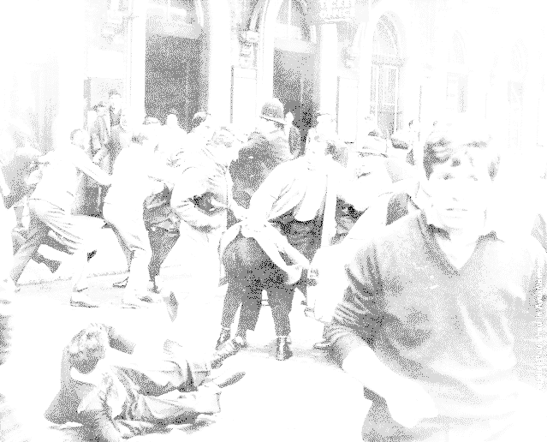](http://www.snipview.com/q/1958%20Notting%20Hill%20race%20riots)

**Was Britain Racist?**

**Short Term Causes**

**Consequences**

**Long Term Causes**