Now Ofsted boss signals return of grammar schools: Bright pupils offered 'high-level academic' path at 14
- Sir Michael Wilshaw was addressing the Confederation of British Industry
- The Ofsted head said pupils could receive a vocational education
- He said pupils could be streamed at 14 to the most appropriate school
- Sir Michael called on industry to train and employ young British people

The head of Ofsted yesterday called for children to be streamed at the age of 14 as part of a radical overhaul of the school system.
Sir Michael Wilshaw said pupils should be directed towards either an academic or vocational school halfway through secondary education.
His blueprint – outlined in a speech to business leaders – will be seen as tacit backing for a revival of academic selection.
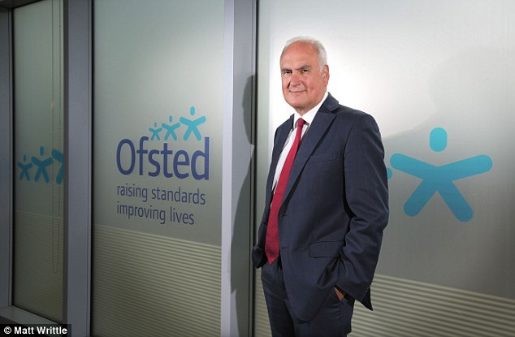

Sir Michael Wilshaw said that pupils should be directed towards either academic or vocational training midway through their secondary education in a speech to the Confederation of British Industry
It follows the revelation that two new grammar schools are being planned in Berkshire and Kent, in what would represent the first major extension of selection by ability for 50 years.
Home Secretary Theresa May is backing plans for a ‘satellite’ grammar in her Maidenhead constituency while Defence Secretary Michael Fallon is supporting a similar scheme in Sevenoaks.
Sir Michael has previously spoken of his opposition to traditional grammar schools, claiming they fail to improve social mobility because they are ‘stuffed full of middle-class kids’.
But in a keynote speech to the Confederation of British Industry, he backed a degree of academic selection later in a child’s school career, at age 14 before they start their GCSE courses.
A ‘fundamental shift’ in school structures was needed, he said.
Under his proposals, schools would form local ‘clusters’ with each developing different specialisms such as highly academic education – similar to a grammar – and vocational qualifications.
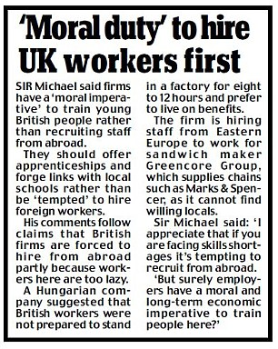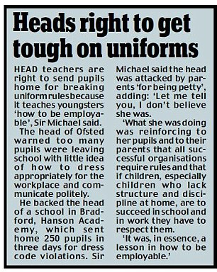

Vocational options might include the existing University Technical Colleges (UTCs), which already take pupils from 14 and teach them skills needed for a trade or industry. ‘Wouldn’t it be good if at least one of the schools in the cluster had particularly strong vocational provision from 14, perhaps in a UTC or a specialist college?’ he said.
‘Young people could then transfer across institutions in the cluster to provide a route to high-level academic or vocational study. Students on either path would be free to access the specialist teaching available in the other and would not be stuck in one route.’
Sir Michael insisted he was not advocating ‘selection at 14’ but ‘maximum opportunity at 14’.
In a newspaper interview foreshadowing the speech, he suggested that children would be assessed ‘in consultation with parents, teachers and employers’ and directed towards a school that best matched their aptitudes at 14 or 16.
‘I am absolutely sure it is going to happen,’ he said.
In his speech, he said the shake-up was needed to ensure all talents were catered for and tackle Britain’s ‘lamentable’ record on providing vocational education.
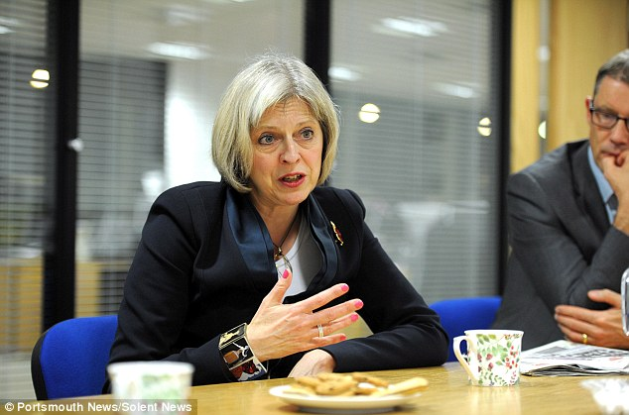

+4
Home Secretary Theresa May is backing the creation of a satellite grammar school in her own constituency
Sir Michael said that figures showed 146,000 jobs are unfilled because companies cannot find staff with the skills they need.
He said vocational education must no longer be seen as a ‘consolation prize’.
Apprenticeships should be held in the same regard as A-levels and ‘sold aggressively’ to young people, he added.
Sir Michael’s plans were immediately welcomed by Lord Baker, the former Tory Education Secretary. He said the speech was ‘most important’ and backed the proposal for clusters of schools with ‘at least one of the schools in the cluster having particularly strong vocational provision from 14 – for instance a UTC’.
Labour passed laws in 1998 banning the opening of any more grammar schools but the Coalition made it easier for the remaining 163 state grammars to open ‘satellites’.

