**Teacher**

    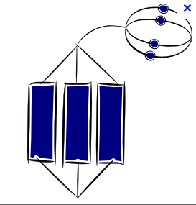   

**My response to the feedback:**

**What I did well:**

**Targets for improvement:**

**I am responding to**

**feedback on:**

* A written assessment.
* Marking in books
* Peer marking.
* Homework
* A learning challenge.

**What I have been studying?**

U G/F E/D C B A A*

None Basic ***Level of understanding*** Joined Up Complex

**P R O G R E S S R E V I E W**