Because…

The Individual

Or Group

Winners or

Losers

[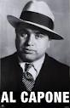](http://www.google.co.uk/imgres?imgurl=http://i642.photobucket.com/albums/uu143/josiahdakillahroyce/al-capone.jpg&imgrefurl=http://www.myspace.com/ilove19942&usg=__jb8YxDEZlJp70YOeGWfsbbZcDsA=&h=450&w=290&sz=18&hl=en&start=15&zoom=1&tbnid=qHtaHHdAFNeQ8M:&tbnh=127&tbnw=82&ei=Rrg7T6u4GOW_0QWA_LRt&prev=/search?q=al+capone&um=1&hl=en&safe=vss&sa=N&biw=1280&bih=800&sout=1&tbm=isch&um=1&itbs=1)

[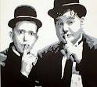](http://www.google.co.uk/imgres?imgurl=http://www.thevioletroom.co.uk/images/Laurel%20And%20Hardy%20Print%205%20A4.jpg&imgrefurl=http://www.thevioletroom.co.uk/index.php?cPath=105_73&osCsid=34a910b55995948f3cbc9859b95ebd7d&usg=__XUU_NhWVmuF0kpCgliSBfi1FNT8=&h=358&w=400&sz=30&hl=en&start=7&zoom=1&tbnid=BI0PNHaEtKDInM:&tbnh=111&tbnw=124&ei=t3A6T-L-Gcak0QXAxOzDCw&prev=/search?q=laurel+and+hardy&um=1&hl=en&safe=vss&sa=N&sout=1&tbm=isch&um=1&itbs=1)

Stan Laurel

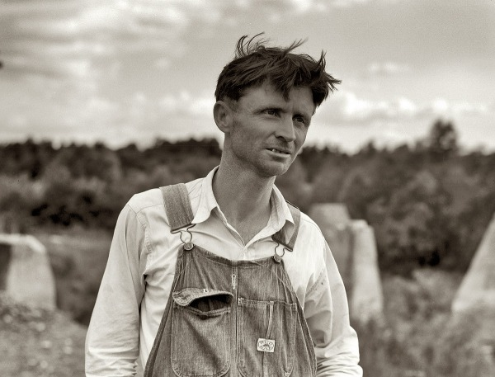

Coal Miner

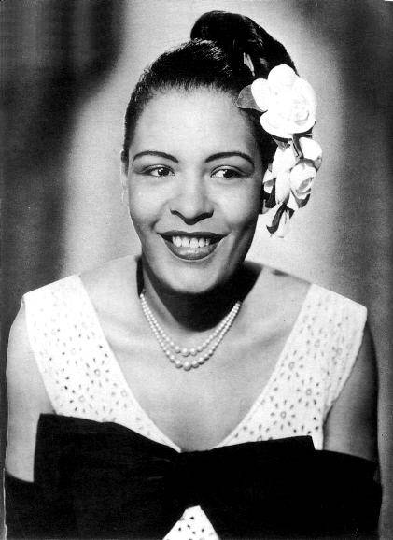

Bessie Smith

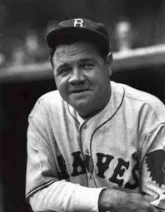

Babe Ruth

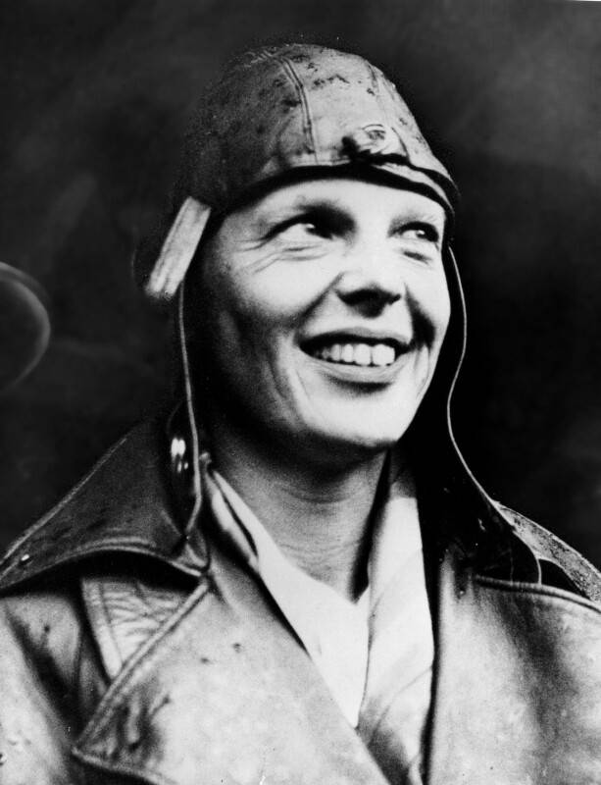

Amelia Earhart