Because…

The Individual

Or Group

Winners or

Losers

[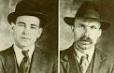](http://www.google.co.uk/imgres?imgurl=http://upload.wikimedia.org/wikipedia/commons/6/63/Sacco_e_Vanzetti.PNG&imgrefurl=http://en.wikipedia.org/wiki/Sacco_and_Vanzetti&usg=__RspZ0NOPMCl67zR3_EwOuoYABNM=&h=238&w=370&sz=152&hl=en&start=3&zoom=1&tbnid=lnvr_aYCBx_dmM:&tbnh=78&tbnw=122&ei=39E8T5y5Jeec0AXo3JXaBw&prev=/search?q=vanzetti&hl=en&safe=vss&biw=1280&bih=822&gbv=2&sout=1&tbm=isch&itbs=1)

Sacco &Vanzetti

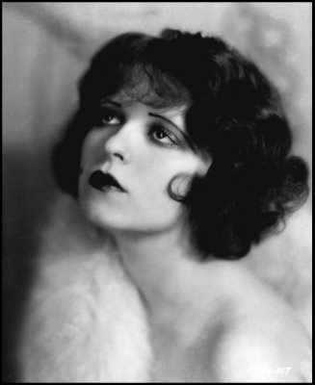

Clara Bow

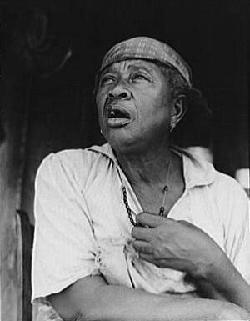

Sharecropper

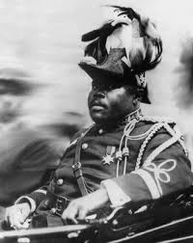

Marcus Garvey

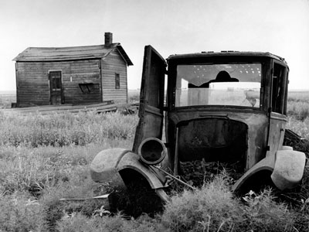

Farmer

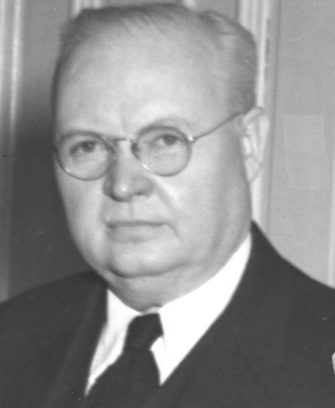

DC Stephenson