Because…

The Individual

Or Group

Winners or

Losers

[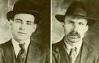](http://www.google.co.uk/imgres?imgurl=http://upload.wikimedia.org/wikipedia/commons/6/63/Sacco_e_Vanzetti.PNG&imgrefurl=http://en.wikipedia.org/wiki/Sacco_and_Vanzetti&usg=__RspZ0NOPMCl67zR3_EwOuoYABNM=&h=238&w=370&sz=152&hl=en&start=3&zoom=1&tbnid=lnvr_aYCBx_dmM:&tbnh=78&tbnw=122&ei=39E8T5y5Jeec0AXo3JXaBw&prev=/search?q=vanzetti&hl=en&safe=vss&biw=1280&bih=822&gbv=2&sout=1&tbm=isch&itbs=1)

Sacco

[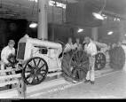](http://www.google.co.uk/url?q=http://blog.thehenryford.org/2013/02/african-american-workers-at-ford-motor-company/&sa=U&ei=Fi8sU9fIBYmr7AakhYDACg&ved=0CDQQ9QEwAw&usg=AFQjCNHk2blSqmLqp_6DxTukt4D1oqmMWA)

Ford Employee

[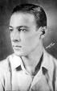](http://www.google.co.uk/url?q=http://en.wikipedia.org/wiki/Rudolph_Valentino&sa=U&ei=ry4sU_jkC4uV7QaCoYD4Cw&ved=0CDAQ9QEwAQ&usg=AFQjCNF9vSGfTZQ5tw-jIGAkn43PlhkBKw)

Valentino

[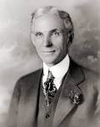](http://www.google.co.uk/url?q=http://pt.wikipedia.org/wiki/Autom%C3%B3vel&sa=U&ei=9C4sU8nsI9Cu7Ab68oGACw&ved=0CC4Q9QEwAA&usg=AFQjCNEawok4_CsQf6_e4SKUeMYPQO4Wyw)

Ford

[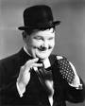](http://www.google.co.uk/url?q=http://www.nndb.com/people/055/000031959/&sa=U&ei=2y4sU_rzMaSh7AbR6YGoCg&ved=0CDAQ9QEwAQ&usg=AFQjCNHL0E34WVrp-dns8Bf_-bDdBnDkWg)

Oliver Hardy

[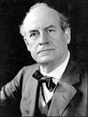](http://www.google.co.uk/url?q=http://www.npr.org/2005/07/05/4723956/timeline-remembering-the-scopes-monkey-trial&sa=U&ei=iy4sU-OTIsfMhAfvx4GoBQ&ved=0CDwQ9QEwBw&usg=AFQjCNHEPfdG1bdd8TlKM6NlirxtA0-QCQ)

Scopes