[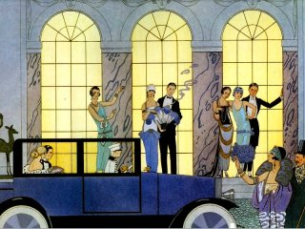](http://cc33charleston.org/wp/2012/10/01/friday-night-social-welcome-to-the-jazz-age/jazzscene/)[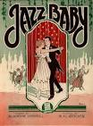](http://www.google.co.uk/url?q=http://www.americaslibrary.gov/jb/progress/jb_progress_fitzgrld_3_e.html&sa=U&ei=BOwiU9DVAoyShQei64DYAg&ved=0CDoQ9QEwBjgo&sig2=BTPByJh9jXaJPC3aqpo9HQ&usg=AFQjCNG-O_VZytYR-cL-4RBdQ14n3kXNhg)













**Cycle of Prosperity**

Cinema

Advertising

Hire Purchase