**Afghan Invasion**[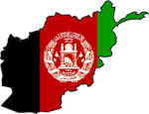](http://www.google.co.uk/url?url=http://mapsof.net/map/afghanistan-flag-map&rct=j&sa=U&ei=xw3VUuDVAtOFhQfLrYHgDw&ved=0CDoQ9QEwBQ&sig2=M2AsA5ae2W4fh9XunhSkYw&q=Afghan+flag&usg=AFQjCNES8687dSb46FJiDwHQ9PAN5OaPeA)