**Reaction of the USA to the Invasion**

**Reasons for the USSR invading Afghanistan**

**Key features of détente?**

**What caused détente?**

[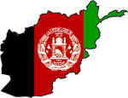](http://www.google.co.uk/url?url=http://mapsof.net/map/afghanistan-flag-map&rct=j&sa=U&ei=yQrVUv7OCpOwhAf68IHwDg&ved=0CDoQ9QEwBQ&sig2=TccffKtGSeDRldVF4R_eZA&q=Afghan+flag&usg=AFQjCNFz5B4ibRp2J0KWD1mR7N6J7pfgpA)

[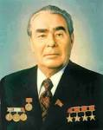](http://www.google.co.uk/url?url=http://www.emersonkent.com/history_notes/leonid_ilich_brezhnev.htm&rct=j&sa=U&ei=AgvVUqm0LYeqhQf6rIHACA&ved=0CDIQ9QEwAQ&sig2=bknJLrM82BFjom1djnu2wg&q=Brezhnev&usg=AFQjCNFszN0KH1-ex95asmH9UMWbABAMSA)

[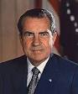](http://www.google.co.uk/url?url=http://en.wikipedia.org/wiki/List_of_federal_judges_appointed_by_Richard_Nixon&rct=j&sa=U&ei=HQvVUt3bHJKqhAeCzoDQBw&ved=0CDIQ9QEwAQ&sig2=Vk3n9Hj8FX6DRvNCMS6VBA&q=Nixon&usg=AFQjCNG35UYtsCkQgjTw_yrAXqqyMpkXEA)

**The Decade of**

**Détente:**

**1969 -79.**

[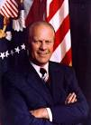](http://www.google.co.uk/url?url=http://theordinarypolitical.wordpress.com/2011/01/07/flashback-friday-gerald-r-ford/&rct=j&sa=U&ei=PAvVUoiaOY6rhAfN3YGICA&ved=0CDwQ9QEwBg&sig2=cKh-dXEen0LeFgvKWO1_wg&q=President+Ford&usg=AFQjCNGNRk40FZ69_S-1xQtC8X84kauFOg)

[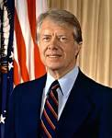](http://www.google.co.uk/url?url=http://en.wikipedia.org/wiki/Jimmy_Carter&rct=j&sa=U&ei=ZgvVUqWdJISihgebhoDYCA&ved=0CDAQ9QEwAA&sig2=oUvGsz-zwjK8nzBCRlyicg&q=President+Carter&usg=AFQjCNEYlDnx6-Be7US5AqypKax7ZSzDuA)