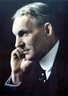

Cycle of Prosperity

How Ford Contributed to the

Cycle of Prosperity.

How Ford Benefitted from the

Cycle of Prosperity.