**The Issue:**

**Berlin Refugee**

**Crisis**

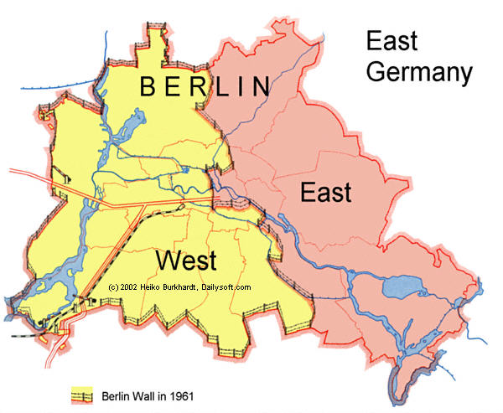

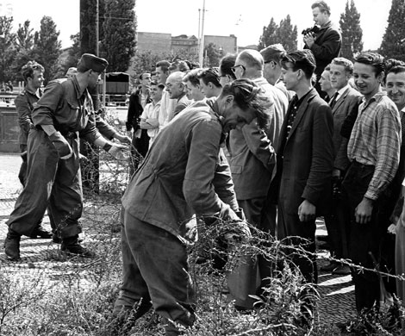

Forces Against Change

Forces for Change