SOLO | Progress Statement | Evidence
Prestructural | - I have never heard of the 3 Crises in Berlin, Cuba or Czechoslovakia.
Unistructural | - I have heard of the 3 Crises in Berlin, Cuba or Czechoslovakia.  - I can give one or two facts about each crisis.
Multistructural | - I can describe causes, events and consequences for each of the 3 Crises we are studying.
Relational | - I can explain in detail how each crisis developed.  - I have a clear understanding of the causes, events and consequences for each crisis.  - I can compare and contrast each of the 3 crises and distinguish similarities and differences.
Extended Abstract  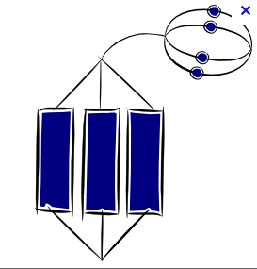 | - I can put each of the crises into the wider context of my studies on the Cold War showing links to other parts of my learning.

