SOLO | Progress Statement | Evidence
Prestructural | - I have no idea what detente means. I have never heard of the Soviet invasion of Afghanistan or why it created a second Cold War
Unistructural | - I have heard of detente.  - I can give one or two facts about the USSR invasion of Afghanistan.
Multistructural | - I can describe what detente is and why it took place in the 1970s.I can explain the reasons for the USSR invasion of Afghanistan and describe the US reaction to it.
Relational  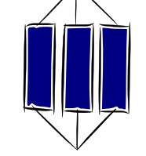 | - I can explain in detail the détente of the 1970s.  - I have a clear understanding of the causes, events and consequences of the Soviet Invasion of Afghanistan.  - I can compare and contrast this crisis and distinguish similarities and differences with previous crises studied.
Extended Abstract  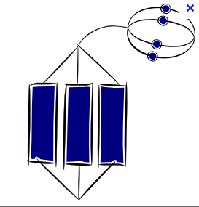 | - I can put the Afghan invasion into the wider context of my studies on the Cold War showing links to other parts of my learning.

