SOLO | Progress Statement | Evidence
Prestructural | - I have no idea what the New Deal was. I have never heard of the Depression Era in the USA.
Unistructural | - I have heard of the New Deal.  - I can give one or two facts about either what the New Deal was, how it was created or its effects.
Multistructural | - I can describe what one or two facts about the New Deal, I can name some of the Alphabet Agencies and I can list some individuals or groups who opposed the new Deal..
Relational | - I can explain in detail the New Deal and how pump priming used the Alphabet Agencies to try and help the most needy and get the US economy working again.  - I can link these causes to underlying economic problems that existed and match agencies to groups and problems. I can explain who opposed the New Deal and why.
Extended Abstract  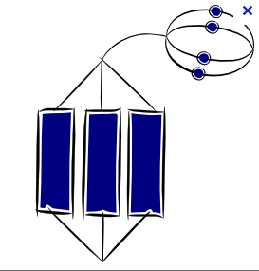 | - I can evaluate the New Deal and assess its success in dealing with the problems of the Great Crash and Depression.
Assessment: | My assessment of this topic will be a choice of an 8 or 16 mark exam style question. | Grade:

