Level of Understanding
 | I have no idea about different ideologies such as capitalism or communism. I do not know what the Cold War is or how it started.
 | I can identify the two sides in the Cold War. I can give a reason for why these two sides began to hate each other. I can give one or two causes or consequences for key events like the Berlin Blockade or the Hungarian Uprising.
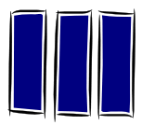 | I can describe some basic facts about communism and capitalism. I can identify the countries and leaders who followed these ideologies. I can list reasons why relationships between east and west got worse and list consequences of this.
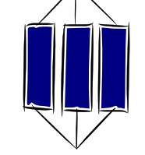 | I can explain why relationships between the capitalist west and communism east got worse between 1943 and 56. I can link this breakdown in relations to strategies like the Truman Doctrine, Marshall Plan and key events like the Berlin Blockade and the Hungarian Uprising. I can see how actions from one side could lead to actions from the other.
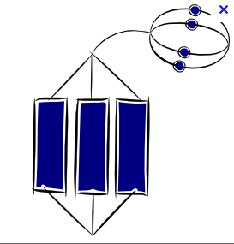 | I am able to demonstrate my understanding of how the Cold War began by showing deep understanding of how two competing ideologies fought for dominance in the post war world and how their actions were influenced by the beliefs, history and distrust of one another. I can clearly see the impact these actions had on nations and people around the world.

