SOLO | Progress Statement | Evidence
Prestructural | - I have no idea what the Wall Street Crash was. I have never heard of the Crash of 1929.
Unistructural | - I have heard of the Wall Street Crash.  - I can give one or two facts about either what the Crash was, how it was caused or its consequences.
Multistructural | - I can describe what one or two facts about what the Crash was, how it started and its effects on the USA.
Relational | - I can explain in detail the four causes of the Wall Street Crash of 1929.  - I can link these causes together and to other underlying economic problems that existed before 1929. I can explain what the consequences of the Crash were on the people and the economy of the USA.
Extended Abstract  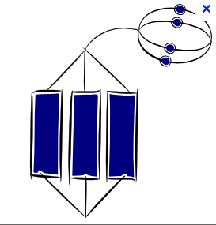 | - I can create a “cycle of depression” diagram based upon my notes and the “cycle of prosperity”. I can see similarities in the present economic problems and those of 1929.
Assessment: | My assessment of this topic will be a choice of an 8 or 16 mark exam style question. | Grade:

