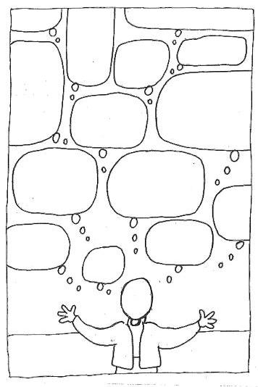

Glasnost

Perestroika

Corruption was too great for big

Economic improvements.

Soviet economic central planning to be made more efficient.

Military conscription

was to be

abolished.

Free speech was allowed.

People were told about the atrocities committed by Stalin.

1000s of political

Prisoners were released from prison and gulags