**G r e a t D e p r e s s i o n T r e a s u r e H u n t**

[](http://www.google.co.uk/url?q=http://richardshear.wordpress.com/2009/08/02/pay-the-artists-they-are-paintbrush-ready/wpa-logo/&sa=U&ei=_v56U9i-MIOd0QX6rIDIDw&ved=0CDQQ9QEwAw&sig2=8e_gUGgXjDKgsaytcJf4FQ&usg=AFQjCNHNTLDYnPEMmenkWtUFwKCpNI_-Bg)





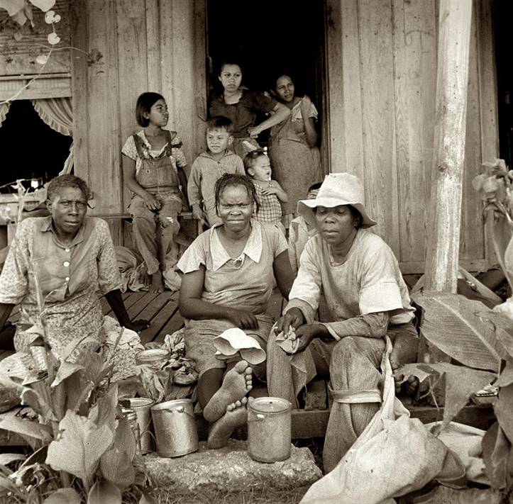

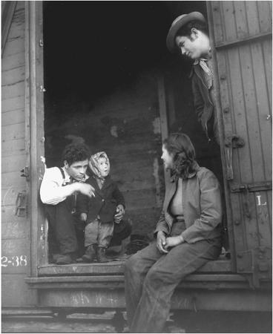

[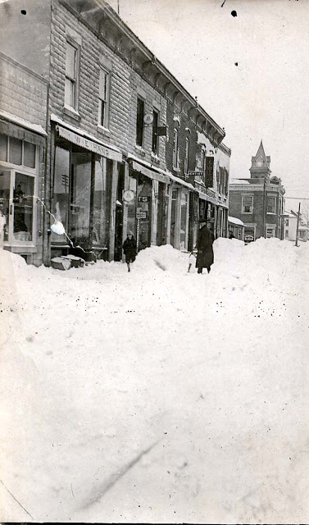](http://1.bp.blogspot.com/_3o9FUDlJrSw/TVCe7RS98HI/AAAAAAAACXY/TEIPKUXS5_8/s1600/main_st_snowstorm_1930s.jpg)

