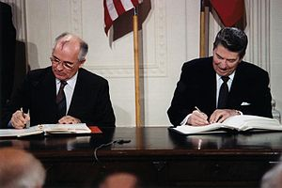
U.S. President Ronald Reagan and Soviet General Secretary Mikhail Gorbachev signing the INF Treaty in the East Room at the White House in 1987.
The Intermediate Range Nuclear Forces Treaty was a disarmament treaty suggested by Gorbachev and signed by Reagan in 1988 that removed all medium range nuclear missiles from Europe.

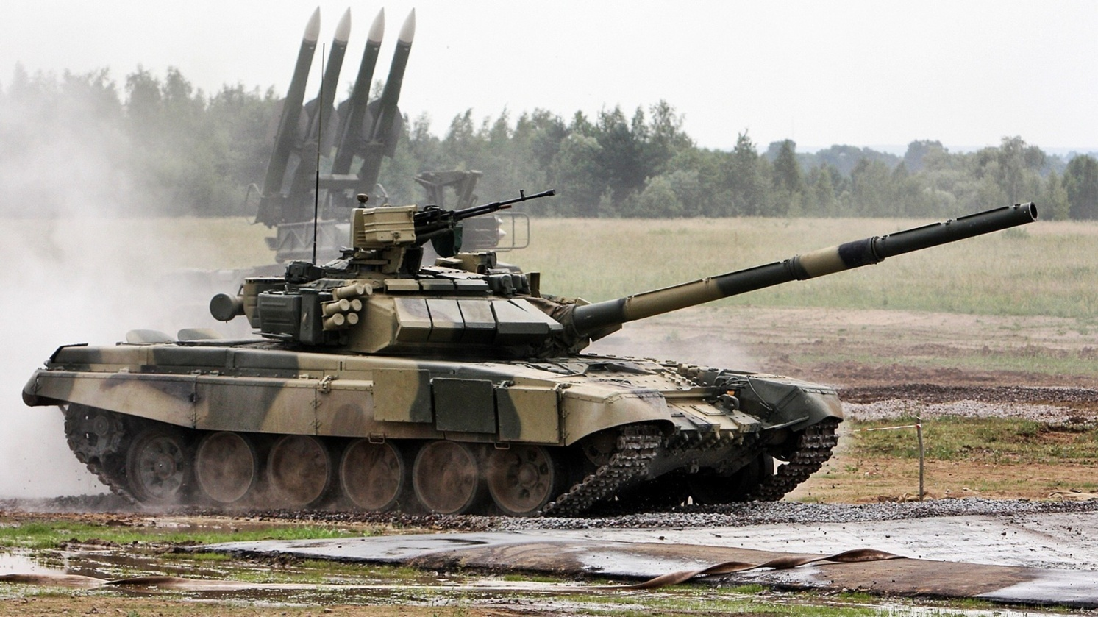
The USSR outnumbered the West in the number of its conventional weapons such as tanks. Even if they were often less technologically advanced than NATO’s weapons.
In 1988 Gorbachev announced an immediate reduction in the Soviet weapons stockpile and a further reduction in the number of soldiers in the USSR army.
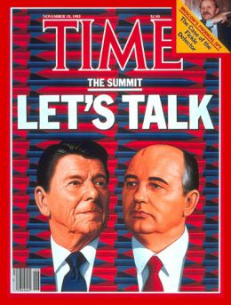
Gorbachev and Reagan met for the first time in 1985 in Geneva.
Several summit meetings followed with both leaders visiting each other’s countries.
Gorbachev tried to reduce the tensions of the second Cold War through meeting with President Reagan. The two men met several times. Gorbachev also visited the USA and became very popular in the West.
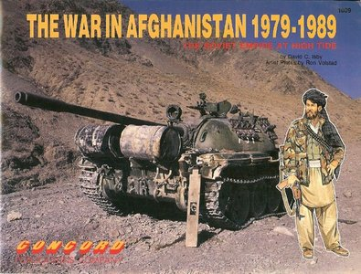
In 1988 Gorbachev announced the complete withdrawal of Soviet forces from Afghanistan.

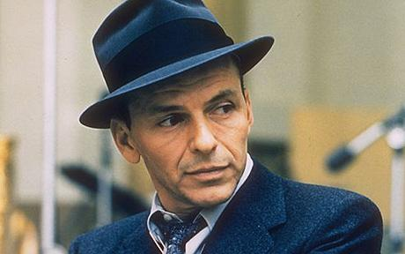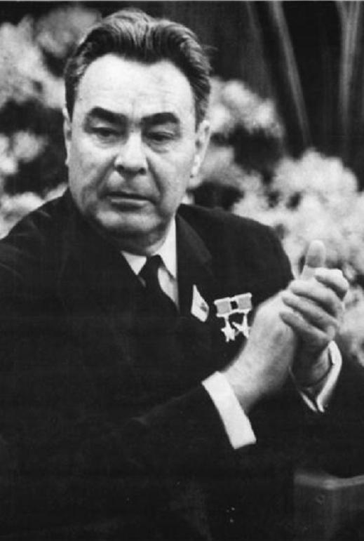
The Sinatra Doctrine –Mikhail Gorbachev used jokingly to describe its policy of allowing neighbouring Warsaw Pact nations to determine their own internal affairs. The name alluded to the Frank Sinatra song "My Way"—the Soviet Union was allowing these nations to go their own way.
Gorbachev abandons the Brezhnev Doctrine in 1988. He tells the United Nations that the countries of eastern Europe are now free to follow their own destinies – the USSR was not going to control them anymore.

